This literature discussion is in honor of Dr. Josh Figueroa, recipient of the 2026 F. Albert Cotton Award in Synthetic Inorganic Chemistry. Josh has done some tremendous work with isocyanide ligands, and this paper is but a brief glimpse into this field. The article (Z. Anorg. Allg. Chem. 2023, 649, e20220320 https://doi.org/10.1002/zaac.202200320) is relatively short but provides wonderful opportunities to have students think about what is in the paper and what is not.

- This is a relatively brief paper that gives a short introduction. In your own words, suggest why this work could be of importance.

- The main ligand of interest in this study is the CNPh^{pF} ligand which is shown in Scheme 2. For now, consider the 4-C₆H₄F group bound to the nitrogen atom to be R. Draw a Lewis structure of CNR and from this, suggest what type (X, Y or Z) this ligand should be. How did you arrive at this conclusion?

- If the R group in the previous question was H, what common ligand would the isocyanide be isoelectronic (same number of electrons) to?

- Describe/depict the orbital interactions between a metal and a terminal CO ligand.

- The results in the table below come from WebMO and were calculated using the Gaussian suite and B3LYP 6-31G(d). Note that there are degenerate LUMOs in both molecules, and only one is represented for each molecule. Based on this information and your chemical intuition, which ligand would you expect to be a better σ-donor? Which ligand would you expect to be a better π-acceptor? Why?

 | CO |  |  | CNH
 | MO | E (eV) |  | MO | E (eV)
HOMO | 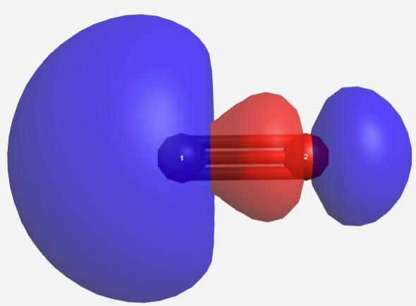 | -10.095 |  | 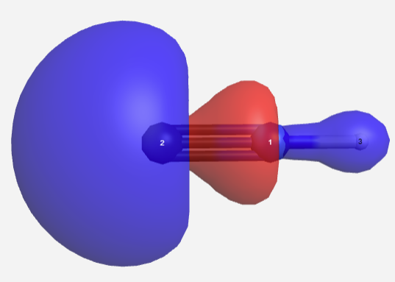 | -8.490
LUMO | 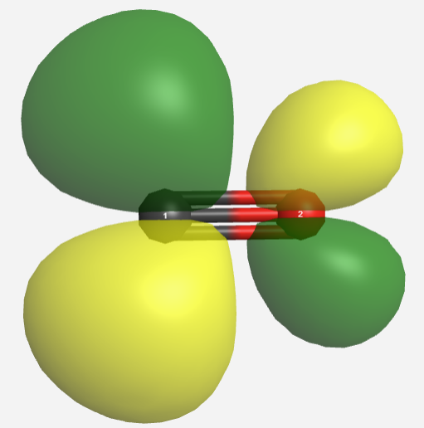 | -0.599 |  | 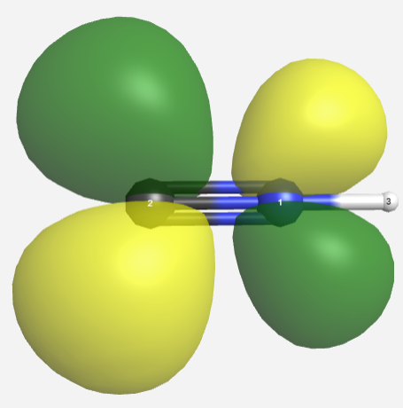 | 0.707

- The starting material in this study is [Re(CO)₅Br] (1). Classify the compound, provide an electron count, the ligand bond number, the valence on rhenium and the d^{n} count for rhenium.

- The two solvents used in this study are tetrahydrofuran (THF) and toluene. What are the boiling points of these solvents? You should be sure to cite your source(s).

- Initially, compound 1 reacts with CNPh^{pF} to give compound 4 in scheme 2. The authors draw this structure with the CNPh^{pF} ligand cis- to the Br ligand. Draw the structure of the other possible isomer for this molecule.

- The formation of compound 4 is a ligand substitution reaction in which one L-type ligand is replaced with another. Although the authors do not mention the mechanism for this reaction, would you think it would be Associative or Dissociative? Why?

- Their only reported evidence for compound 4 is the ¹⁹F NMR spectrum of reaction mixtures in which there is a peak noted in the top two spectra in Figure 1. Is the presence of this single peak at 109.3 ppm sufficient evidence for the proposed isomer of compound 4 in Scheme 2? Why or why not?

- Both the carbonyl ligands and the CNPh^{pF} ligand would give strong bands in the infrared spectrum. As the authors were unable to isolate compound 4, they do not the IR spectrum for the compound. Using group theory and considering both the carbonyl and CNPh^{pF} ligands, would you be able to distinguish between the isomers of compound 4?

- Continued heating of the reaction mixture results in the formation of compound 5 in which the CNPh^{pF} ligands are cis-. There are two other possible isomers for this compound which are shown below. The IR spectrum of compound 5 is reported and displays two CN vibrations and three CO vibrations. Using group theory, determine if the IR spectrum is sufficient to determine which of the three isomers formed.

- The ¹⁹F NMR spectrum for compound 5 displays a single peak at -107.5 ppm. Considering the information in the previous question, do you agree with the assigned structure of compound 5? Why or why not?

- The IR spectrum for compound 1 has been reported (Li, C.; Guo, L; Garland, M. Organometallics 2004, 23, 5275). There are three vibrations in the carbonyl region: 2046, 2016 and 1986 cm⁻¹. Compare this to the ν_{CO} bands in the IR spectrum of compound 5. What does this tell you about the nature of the CNPh^{pF} ligand as compared to a carbonyl? You might want to review your answer to question 5.

- The authors also provide some insight into this idea by saying “The IR spectrum of 5 shows the ν_{(CO)} stretches at 1916, 1973 and 2026 cm⁻¹, while the ν_{(CN)} bands appear at 2153 and 2183 cm⁻¹. The latter values are higher than that of the uncoordinated isocyanide (2129 cm⁻¹), which suggest that the isocyanide does not act as a π-acceptor in compound 5.” Explain how the authors are able to reach this conclusion.

- Using the information from the previous question, what does the IR for compound 5 suggest about the CN bond strength in the coordinated CNPh^{pF} relative to that of the free ligand? How can explain this? (Hint: you might go back to question 5 for this).

- In preparing compound 6, the authors needed to change solvents from THF to toluene. In light of the previous two questions and your proposed mechanism in question 9, why do you think this change was necessary? As part of your discussion, you should consider how enthalpy (ΔH) and entropy (ΔS) play a role.

- The authors report that the ¹⁹F NMR spectrum for compound 6 displays a single peak at -110.7 ppm. How does this suggest that the authors are proposing the correct isomer for compound 6?

- The authors also report one band for the ν_{CN} and two bands for the ν_{CO} in the IR spectrum for compound 6. Does this make sense for either of the two possible isomers? Why or why not? You should use group theory to support your answer.

- With regard to compound 6 the authors state that “unlike in compound 5 also the ν_{(CN)} frequency (2065 cm⁻¹) is bathochromically shifted against the value in the uncoordinated isocyanide indicating that CNPh^{pF} participates in the withdrawal of electron density from the d⁶ ion by π-backbonding in the tetrakis complex.” In your own words, what does this mean?

- Confirm that there is no redox reaction that takes place in the formation of compound 7 by classifying compounds 6 and 7. Provide electron counts, ligand bond numbers, valence and d^{n} counts for rhenium in each of these compounds.

- What is the purpose of adding the NaBPh₄ in the formation of compound 7?

- The structure of compound 7 can be compared to that of [Re(CO)₆][ReF₆] which was previously reported (Bruce, D.M.; Holloway, J.H.; Russell, D.R. J. Chem. Soc.: Dalton Trans. 1978, 1627). In one of the compounds the average ReC distance is 1.991 Å while in the other it is 2.033 Å. The IR spectrum of [Re(CO)₆][ReF₆] has also been reported (Holloway, J.H.; Senior, J.B.; Szary, A.C. J. Chem. Soc.: Dalton Trans.1987, 741) and is shown below. Based on this information, which ReC bond length likely corresponds to which compound? Why?

 | L = CO | L = CNPh^{pF}
ν_{CX} for free L (cm⁻¹) | 2143 | 2129
ν_{CX} for [ReL₆]⁺ (cm⁻¹) | 2086 | 2074
Re-C (Å)

