The Synthesis and Characterization of trans-Dioxorhenium(V) Complex
Synthetic Procedure (Week 1)
Measure out 0.269 g (0.323 mmol) of ReOCl₃(PPh₃)₂, 0.5 mL (6.46 mmol) of pyridine, 5 mL acetone, and 0.25 mL of distilled water. Place all chemicals into a 50-mL round bottom flask with a stir bar. Purge the reaction mixture with argon for 15 minutes. Reflux for 90 minutes under argon (Fig 1). Cool the reaction mixture. Place in an ice-bath for 30 minutes. Filter the orange-yellow product and wash with ether (1-mL) and toluene (1-mL). DO NOT WASH YOUR PRODUCT WITH H₂O!

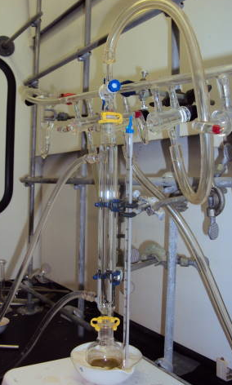
Characterization of your product (Week 2)
- Weigh your product and determine the percent yield.
- Collect an IR spectrum of your sample.
- Your team will acquire the UV-vis spectra for your sample. Determine the quantitative aspects of the compound’s electronic absorption spectrum in water solution. Report the wavelengths of maximum absorbance and the molar absorptivities (Beer’s Law) at each of the wavelength maxima.
- Collect a ¹H NMR spectrum (DMSO-d) of your product and determine the coupling constants (J) for the protons.
- You will use computational chemistry to understand the UV-vis spectroscopic data. (You will visualize the molecular orbitals using GaussView. You can download this software on your laptop from the IT webpage.)
- You will visualize the molecular vibrations of the molecule using the output results in the GaussView interface.

Note: The instructor will provide your team with the output results from density functional theory (DFT) to visualize the MOs and molecular vibrations of the molecule.
Fig. 1. Reflux apparatus (Liam Pender)

Clean Up. Clean all the glassware with warm water and rinse with distilled water.
References:
Ram et al. Inorg. Chem, 1990, 29, 238-244
Ram et al. Inorg. Chem, 1991, 30, 130-133

