What elements belong in group 3 of the periodic table?

Eric R. Scerri, William Parsons
Department of Chemistry & Biochemistry
UCLA
Los Angeles
CA 90095

Introduction
The question of precisely which elements should be placed in group 3 of the periodic table has been debated from time to time with apparently no resolution up to this point. This question has also received a recent impetus from several science news articles following an article in Nature Magazine in which the measurement of the ionization energy of the element lawrencium was reported for the first time.
We believe that this question is of considerable importance for chemists, physicists as well as students of the subject. It is the author’s experience that students are typically puzzled by the fact that published periodic tables show variation in the way that group 3 of the periodic table is displayed. Instructors typically cannot answer questions that students may have on this matter. The aim of the present article is to make a clear-cut recommendation regarding the membership of group 3, which we believe, should consists of the elements, scandium, yttrium, lutetium and lawrencium.
Although the arguments in favor of replacing lanthanum and actinium by lutetium and lawrencium are rather persuasive there is a popular and mistaken belief that IUPAC supports the traditional periodic table with lanthanum and actinium in group 3. This view has been disputed by Jeffrey Leigh in an interesting article in which he made it clear that IUPAC has not traditionally taken a view as to the correctness of one or other periodic table and that there is no such thing as an officially approved IUPAC periodic table.
We will briefly review the previous arguments that have been provided in favor of moving lutetium and lawrencium into group 3 of the periodic table in place of lanthanum and actinium. We will then reiterate what we take to be a categorical argument in favor of this placement and will discuss any remaining issues. When added to the previously made arguments over a period of over 50 years it becomes clear that the time may have arrived for IUPAC to make a ruling on this question.

A historical survey of evidence and arguments in favor of placing Lu and Lr into group 3
Since the advent of quantum mechanics and the precise determination of the electronic configurations of atoms there has been a general belief that such an approach should settle any remaining questions having to do with the details of the periodic table. Although we believe this premise to be incorrect we will begin by discussing evidence based on the electronic configurations of some of the atoms in question.
The early determination of the configurations of the elements ytterbium (70) and lutetium (71) seemed to indicate the following electronic configurations for their atoms.

Yb [Xe] 4f¹³ 5d¹ 6s²
Lu [Xe] 4f¹⁴ 5d¹ 6s²

As a consequence it was believed that lutetium should mark the end of the lanthanide series. In addition the discovery of lutetium had occurred at about the same time as the discovery of several other rare earth elements, which meant that it was generally regarded as simply being a rare earth element.
In 1937 an article was published by Meggers and Scribner in which they reported that contrary to earlier observations the configuration of ytterbium should be assigned as,

Yb [Xe] f¹⁴ 6s²

Nevertheless, the authors did not comment on any possible ramifications for the placement of the subsequent element lutetium in the periodic table. For the sake of clarity we will briefly discuss this consequence now. If ytterbium possesses 14 f-electrons, rather than 13 as formerly believed, it can genuinely be thought of as the final rare earth element. Consequently, the next element, lutetium, can be regarded as a d-block element, thus placing it under scandium and yttrium in group 3. In the years following this discovery a few books and published periodic tables incorporated the newly assigned configuration of ytterbium but still refrained from discussing any possible reassignment of the placement of lutetium.
The first statement that we have been able to find that these configurations provided grounds for regarding lutetium as a d-block rather than as an f-block element comes from the well known, perhaps even classic, book on quantum mechanics by Landau and Lifshitz in 1959. Here the authors stated categorically that,

In books on chemistry, lutetium is also placed with the rare earth elements. This, however is incorrect, since the 4f shell is complete in lutetium...

It would appear that this simple notion was then rediscovered separately by a number of other authors, working in different sub-disciplines, although none of these proposals seemed to have any impact on the way in which the periodic table was presented in textbooks or elsewhere with the possible exception of the work of Luder. Several of the authors who proposed that lutetium should replace the element lanthanum in group 3 were physicists, a factor that may have contributed to their being ignored by the chemical community.
In 1982 a major development took place in the story of what elements to place in group 3. William Jensen published a widely cited article in Journal of Chemical Education in which he reviewed previous evidence and made perhaps the first concerted plea, to chemists, for periodic tables to be changed so that lutetium should replace lanthanum and lawrencium should replace actinium in group 3. It would seem that this article has not convinced many authors since the majority of periodic tables have remained unchanged and the debate has continued to exist.

Brief analysis of Jensen’s article of 1982
We believe that the article by Jensen represents a major step towards the reassignment of the elements lutetium and lawrencium to group 3 but that the proposal suffers from some limitations that have resulted in its not having the impact that might have been hoped for.
The first limitation is rather minor but nevertheless worth mentioning in this context. While reporting the reassignment of the configuration of ytterbium Jensen wrote,

More recent spectroscopic work, however, has revised the earlier electronic configurations (4). Only three of the rare earths in period 6 (La, Gd, and Lu) are now known to have the ground state [Xe]4f^{x - 1}5d¹6s², all of the rest having the configuration [Xe]4f^{x}6s²… Ytterbium and nobelium should now have configuration [Noble Gas](n – 2)f¹⁴(n – 1)d¹ns² resulting in a d rather than an f differentiating electron for both lutetium and lawrencium and making them equally good candidates for the first members of the d-block in periods 6 and 7… both lanthanum and actinium should be considered the last members of the f-block (rather than Lu and Lr), and lutetium and lawrencium (rather than La and Ac) should be considered the first member of the d-block in periods 6 and 7 and assigned to Group IIIB along with scandium and yttrium.

It appears that Jensen did not take the trouble to investigate just when the assignment had first been proposed since it was a matter of about 50 years rather than due to “More recent spectroscopic work”. If anything this makes it more puzzling that the relocation of lutetium was not seriously considered in earlier times.
The second limitation is that we believe that Jensen has been too selective in the evidence he puts forward in order to support his case. We will show that if other forms of data are appealed to, the case becomes somewhat less compelling.

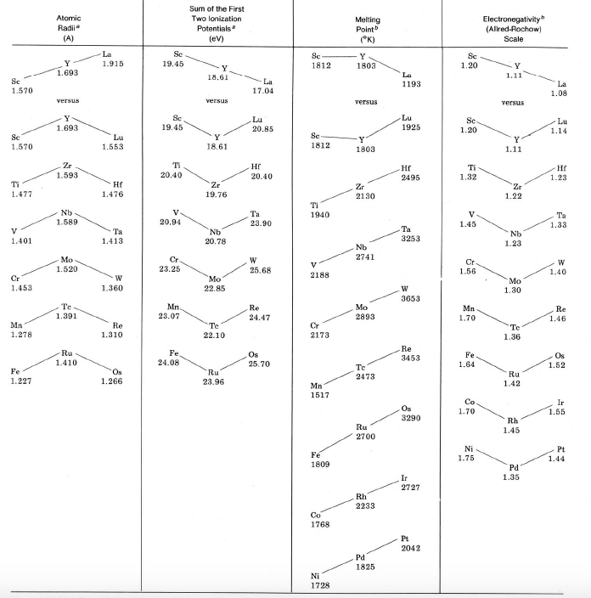

Figure 7.1. Jensen’s re-presentation of Christyakov’s data.

It should also be mentioned that Jensen was not personally responsible for assembling this particular data or in presenting it in the fashion shown in his article. As Jensen acknowledges, he was using the data collected and plotted some years earlier by Christyakov. In fact this data is somewhat more comprehensive than what Jensen chose to display in his 1982 article and again one could say that he is introducing a further element of selectivity in his choice of what evidence to omit from Christyakov’s article.
In order to investigate more thoroughly the kinds of trends that Christyakov and Jensen appeal to we set out to examine how several other properties vary among elements in several transition metal groups. For example, it is not at all clear why Christyakov and following him Jensen, have chosen to focus only on the sum of the first two ionization energies of the elements in question rather than say the sum of the first three ionization energies. The latter quantity is in fact more relevant given the overwhelming tendency of actinides to form ions with a +3 charge.

Sum of first three ionization energies.
A casual inspection of figure 2, in which the sum of the first three ionization energies is plotted, shows that lanthanum fits the general downward trend among transition group elements better than does lutetium. In the case of lutetium there is a slight increase which appears to be anomalous since none of the other sets of transition metal groups show an increase in the value for the final member of the group, apart from group 12. This feature emphasizes the fact that appealing to specific chemical or physical data on the elements in question is inconclusive.

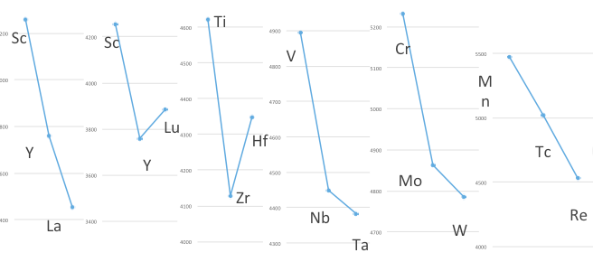
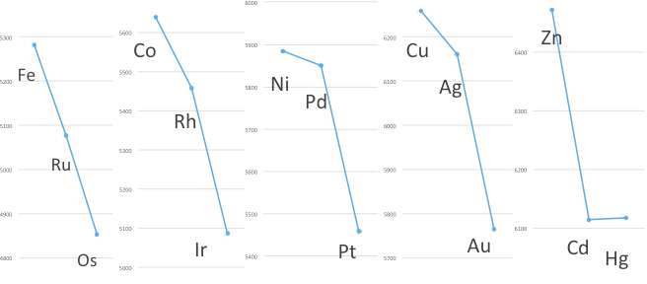
Figure 7.2. Sum of first three ionization energies in kJ/mol for first three elements in groups 3 to 12 inclusive.

The data for group 3 metals in figure 2 is presented in two ways, first with lanthanum and secondly with lutetium in place of lanthanum. Lanthanum seems to conform to the general downward trend better than lutetium, contrary to Jensen’s argument. This underlies the inconclusive nature of arguments based on specific chemical and physical data.

A conclusive argument in favor of Sc, Y, Lu, Lr
What is required in order to settle the membership of group 3 seems to be a conclusive argument that so far has not been presented in this article. As we have seen, arguments drawing on changes in electronic configuration are suggestive of the need to replace lanthanum with lutetium but by no means conclusive. Similarly the chemical and physical data first presented by Christyakov, and represented more recently by Jensen, also support the replacement of lanthanum with lutetium but are also not conclusive. We have seen that in the case of ionization energy, focusing on the more relevant sum of the first three ionization energies leads to the conclusion that lanthanum should not be replaced.
Let us return to the need for a completely general and conclusive argument that does not depend of individual data on the elements concerned or their electronic configurations. Such an argument has been published. It depends on two very modest requirements. The first is to present the periodic table in a 32-column long format rather than the more frequently displayed medium-long or 18-column format. The long form can be said to be a more correct representation given that it incorporates the f-block into the main body of the periodic table. In the 18-column table the f-block appears as a disconnected footnote but this format has survived for pragmatic reasons. The 32-column table is rather wide with the result that it becomes difficult to represent on wall charts or even on the printed page since the size of each element symbol must be rendered smaller than in the 18-column version. However it is generally accepted that this is merely a pragmatic consideration.
The second modest requirement is that the elements be presented in such a fashion so that they show a smooth increase in atomic number as one progresses through the periodic table from left to right across each period. If these two recommendations are followed it becomes quite clear that group 3 should contain lutetium and lawrencium rather than lanthanum and actinium. As can be seen in figure 7.3, this arrangement makes for a smooth and regular sequence in the atomic numbers of all the elements. On the other hand if one insists on retaining lanthanum and actinium in group 3, the sequence of increasing atomic number becomes highly anomalous as highlighted in figure 7.4.

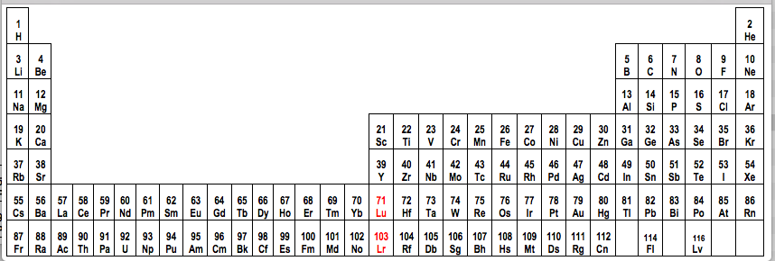

Figure 7.3. Long-form periodic table with lutetium and lawrencium in group 3. The increase in atomic number shows no anomalies whatsoever.

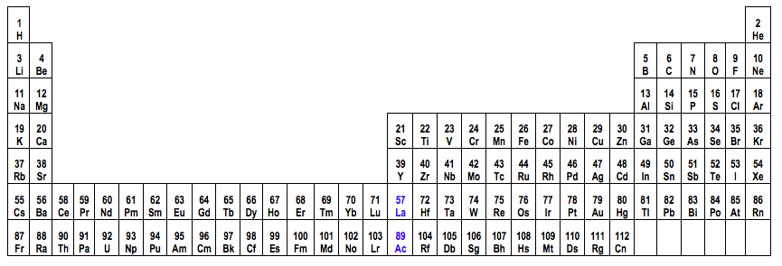

Figure 7.4. Long form periodic table with lanthanum and actinium in group 3. Atomic number no longer increases in a regular fashion. This suggests that La and Ac are misplaced.

Finally, for the sake of completeness we should point out that there is another remote possibility that would still preserve the traditional placement of lanthanum and actinium in group 3 while still showing all elements with a regular increase in atomic number. This is a form of the long-form periodic table, which is occasionally seen in textbooks and articles. However it comes at a high price. As can be seen in figure 5, this presentation of the periodic table requires that the d-block elements be split into two highly uneven parts, one consisting of just one group, while the remaining nine groups of d-block elements are shown together. Nowhere else in the periodic table does this occur causing one to think that it is a rather unnatural presentation that can be safely neglected.

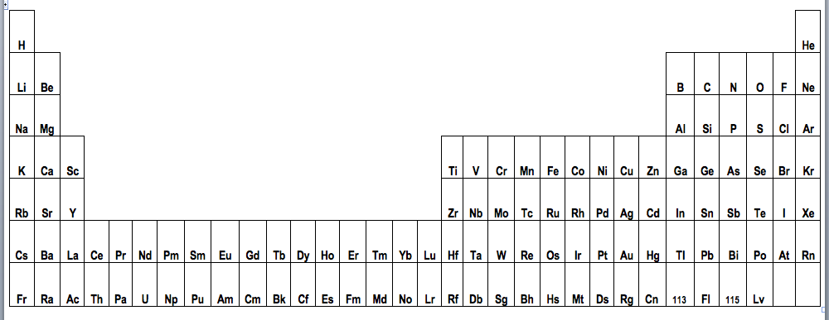
Figure 7.5. Alternative version of long-form periodic table in which the d-block is split into two highly uneven portions consisting of one and nine groups of elements.

Finally, some very recent work that we have carried out suggests that the viability of the ‘split d-block option’ displayed in figure 7.5 is even more improbably than has previously been believed. We now add a third requirement to the criteria that should be used in selecting an optimal periodic table. Up to now we have required that the periodic table be displayed in 32-column format and secondly that the elements should follow each other sequentially in terms of increasing atomic number. As the reader may recall this allowed us to rule out the option presented in figure 7.4 but not the one shown in figure 7.5. We now propose to add the requirement that in progressing sequentially through the blocks of the periodic table, one should adhere to both parts of the Madelung Rule, namely that the order of orbital filling should proceed with increasing values of n +  and in cases of equal values of n +  in an increasing order of the n quantum number.
If one accepts this proposal t becomes clear that the splitting of the s-block of the periodic table, which is routinely carried out in periodic tables that maintain helium in the noble gas group, is categorically different from the split d-block option of figure 7.5. Simply stated, the familiar splitting of the s-block does not violate either parts of the Madelung Rule. On the other hand, the split d-block periodic table entails a violation of the second part of Madelung’s rule as will be explained below.
As can be seen in figure 7.5, the split d-block table features the following two sequences of elements in the sixth and seventh rows respectively. In the sixth row we encounter barium followed by lanthanum, which is followed in turn by cerium.
Focusing now on the blocks of the periodic table that are crossed on moving through these three elements we find the sequence of s-block, d-block and then f-block. More specifically the values of sum of the n +  quantum numbers and n for these atoms appear as follows,

 | Ba | La | Ce
differentiating electron | 6s | 5d | 4f
n +  | 6 | 7 | 7
n | 6 | 5 | 4

Whereas the first part of Madelung’s rule is obeyed on moving through the three elements, the movement from lanthanum to cerium shows a violation of the second part of the rule since for the same value of n + , namely 7, the sequence should follow the order of increasing n whereas this case shows a decrease from 5 to 4.
In the seventh period a precisely analogous case can be made for the atoms of radium, actinium and thorium.

 | Ra | Ac | Th
differentiating electron | 7s | 6d | 5f
n +  | 7 | 8 | 8
n | 7 | 6 | 5

We acknowledge that the Madelung rule does not always give the correct order of occupation of orbitals for a particular atom, such as in the case of scandium. However, apart from about 20 anomalies the Madelung rule does provide the order of orbital occupation as one moves through the periodic table. For example, in the case of potassium and calcium the 4s orbital is indeed preferentially occupied whereas in scandium it is the 3d orbitals that are preferentially occupied. The distinction between order of filling in a particular atom starting from a bare nucleus and order of filling as one progresses through the periodic table has been recently stressed in the literature.
Moreover, for the purposes of selecting an optimal periodic table we prefer to consider block membership as a global property in which we focus on the predominant differentiating electron. We readily acknowledge the fact that the atoms of Mn, Zn, Tc, Cd, Pt, Hg, Lr, La, Gd, Ac, Th and Cm are all anomalous in that they have a differentiating electron that is atypical of the block that they are situated in. These anomalies should not challenge our attempts to establish the overall structure of the periodic table in terms of sequences of blocks in the periodic table and as a result our recommendations fro the membership of group 3 of the table.
Similarly, we draw attention to the fact that there are anomalous cases such as the atom of thorium which features no f-orbital electrons and yet nobody disputes that this element should be housed in the f-block of the periodic table.
The hoped for categorical argument for claiming that group 3 should consist of Sc, Y, Lu, Lr has therefore been strengthened, although admittedly not rendered completely categorical, by means of our further requirement for the adherence to both parts of the Madelung rule on progressing through the periodic table. We suggest that this further requirement makes the split d-block periodic table an even weaker possibility. In addition we do not need to appeal to arguments involving the aesthetic undesirability, or asymmetry of splitting the d-block into two unequal portions consisting a one-group and a nine-group part.
To conclude, there is now highly persuasive evidence as well as a rather categorical argument to support the placement of lutetium and lawrencium into group 3 of the periodic table in place of lanthanum and actinium. We strongly recommend that IUPAC support this proposal and make an official ruling on the matter.

References R.W. Clark, G.D. White, J. Chem. Educ., 85, 497, 2008; W.B. Jensen, 59, 634, 1982. L. Lavelle, J. Chem. Educ., 2008, 85, 1482–1483; E.R., J. Chem Educ., 86, 1188-1188, 2009; W.B. Jensen, J. Chem. Educ., 2008, 85, 1491, 2008; E. Scerri, A Very Short Introduction to the Periodic Table, Oxford University Press, Oxford, 2013.
T. K. Sato et al, “Measurement of the First Ionization Potential of Lawrencium, Element 103” Nature, 520 (09 April), 209-212, 2015.
D. Castelvecchi, “Exotic Atom Struggles to Find Its Place in the Periodic Table,” Nature, 2015, 08 April, http://www.nature.com/news/exotic-atom-struggles-to-ﬁnd-it s-place-in-the-periodic-table-1.17275 ; J. Kemsley, “Lawrencium Ionization Energy Measured,” Chem. & Eng. News, 2015, 93(13 April), 8; M. Gunther, “Lawrencium Experiment Could Shake Up the Periodic Table,” Chemistry World, 2015, 09 April, http://www.rsc.org/chemistryworld/2015/04/lawrencium-exp eriment-could-shake-periodic-table ; R. Gray, “Is the Periodic Table Wrong? Elements May Need to be Reordered After Scientists Find Lawrencium Looks Out of Place,” Daily Mail, 2015, 10 April, http://www.dailymail.co.uk/sciencetech/article-3033570/Is-periodic-table-WRONG-Elements-need-reordered-scientists-L awrencium-looks-place.html
J. Leigh, Chemistry International, Vol. 31 No. 1, January-February 2009 http://www.iupac.org/publications/ci/2009/3101/1_leigh.html
Since the writing of this article IUPAC has approved the formation of a task group to discuss the constitution of group 3 and to make recommendations to them. The task group is under the chairmanship of one of us (E.S.).
C.H. Evans, Episodes from the History of the Rare Earth Elements, Springer, Berlin, 1996.
W.F., Meggers, B.F., Scribner, J. Research National Bureau of Standards, 19, 651, 1937.
L.D., Landau, E.M., Lifshitz, Quantum Mechanics, Pergamon, London, 1959, p. 245 footnote.
W. F. Luder, J. Chem. Educ., 20, 21, 1943.
D.C. Hamilton, M.A. Jensen, Phys. Rev. Letters, 11, 205, 1963;M.A. Jensen, Phys. Rev. Letters, 1963; B.T. Matthias, W.H., Zacharisen, G.W., Webb, J.J. Englehardt, Phys. Rev. Letters, 18, 781, 1967.
W.B. Jensen, J. Chem. Educ., 1982, 59, 634-636.
Some authors did place lutetium and element 103 in the same group as scandium and yttrium but for quite different reasons. One such example is Charles Janet, see P. Stewart, Foundations of Chemistry 12, 5–15, 2010.
V.M. Christyakov, Zh. Obshch. Khim., 38(2), 209, 1968.
E. Scerri, A Very Short Introduction to the Periodic Table, Oxford University Press, Oxford, 2013, chapter 10.
S-G. Wang, W.H.E. Schwarz, The Icon of Chemistry, Angewandte Chemie International Edition, 48, 3404-3415, 2009; E.R. Scerri, The Trouble with the Aufbau Principle, Education in Chemistry, November issue, 24-26, 2013.
S. Salehzadeh, F. Maleki, The 4s and 3d subshells: Which one fills first in progressing through the periodic table and which one fills first in any particular atom? Foundations of Chemistry, 18, 57-65, 2016.

