The following questions refer to the article “Crystal Structure Determination of the Pentagonal-Pyramidal Hexamethylbenzene Dication C₆(CH₃)₆²⁺” by Malischewski and Seppelt, published Angewandte Chemie International Edition in 2017, volume 56, pages 368-370 (DOI: 10.1002/anie.201608795). In this exercise you will use the skills you have learned to look at a purely organic molecule through the lens of Inorganic Chemistry. You will want to refer to your answers to the pre-class exercise.
By now, you should have the following:
- A π-MO diagram of [Cp*]⁻.
- Information about the HOMO and LUMO of CH₃⁻.

We now want to put these together an overall MO diagram of the compound. Let’s line these up in a single figure:

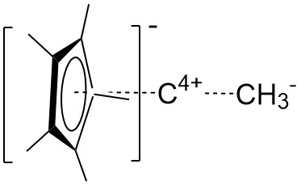

If you keep in mind that the methyl groups spins, and can be thought of as cones (so, for purposes of symmetry, can be thought of as “large hydrogen atoms”), identify the point group of this entire assembly:

Point group ____________
Assign new symmetry labels to the π-MOs on Cp*⁻ (from your pre-class worksheet) in this new point group.

Now those on C⁴⁺:

2s:
2p_{z}:
2p_{x,y}:

And, finally, the lone pair on [CH₃]⁻:

We want to construct an MO diagram that shows the important orbitals for bonding to the central carbon, since that is the one that supposedly has six bonds. First, we notice that the π-MO diagram of Cp*– has an A₁ orbital, the C⁴⁺ atom has two A₁ orbitals, and the CH₃– fragment has one A₁ orbital.
There are many ways to approach the question of how to decide how much of each A₁ orbital on C interacts with each A₁ orbital on the two other fragments, but the easiest approach is to create two sp-hybrid orbitals on the C⁴⁺ atom. Draw these. Are they still A₁?

Now we are ready to start constructing our overall MO diagram. First combine the C⁴⁺ with the CH₃⁻, remembering that σ and σ* orbitals become very low and high in energy because of good overlap. Ignore the Cp^{*−} for now. We can assume that the sp-hybrid orbitals are the same energy as the methyl HOMO, and remember that the E₁ orbitals are higher.
(Hint: Which A₁ orbital(s) can overlap with the CH₃– orbitals?)

Check with your instructor before moving on

Now we can combine [CCH₃]³⁺ with Cp^{*-}. Assume your only remaining non-bonding sp hybrid orbital is the same energy as the A₁ orbital on Cp^{*-}, and remember that pi bonds and pi antibonding typically go less far down and up than sigma bonds because of poorer overlap, so the order of your orbitals should be (lowest-to-highest): σ, π, non-bonding, π*, σ*. Be sure to label each orbital with its symmetry and fill in the electrons in your final MO diagram. Also indicate the HOMO and LUMO of the compound. Using your completed MO diagram, how many “bonds” are between the (CCH₃)₅ group and the central carbon? In other words, does the six-coordinate geometry make sense?

