Smelting with Thag and Friends (h/t Gary Larson)
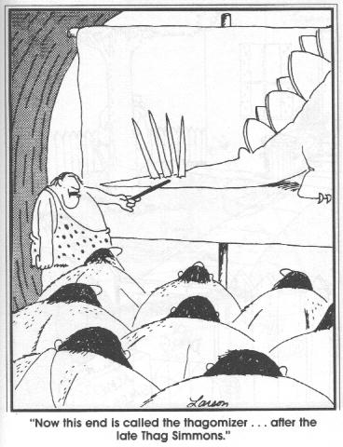
Once, long ago, Thag, Wiga, Ug, and Oge were sitting around the campfire, lamenting the absence of shiny objects. Please help our intrepid cavepersons smelt metal.

Copper is typically found in nature as an ore. The most common of these are malachite and azurite, which are mixtures of cupric carbonate and cupric hydroxide. These easily decompose to form cupric oxide with a little roasting:

$$\text{Cu}({\text{CO}}_{3})\vec{\text{heat}}\text{CuO}+{\text{CO}}_{2}$$
$$\text{Cu}(\text{OH})_{2}\vec{\text{heat}}\text{CuO}+H_{2}O$$

Even after the campfire has done this little number on our ore, our technologically challenged troglodytes must find some way to convert the oxide to the metal itself, if they are to upgrade from flint to copper. Given that the ${ΔG}_{f}^{0}$ of copper(II) oxide is -129.7 kJ/mol, please write a balanced equation and calculate the ${ΔG}_{\text{rxn}}^{0}$for the conversion of cupric oxide to copper and oxygen gas.

Is this a spontaneous process? Under what conditions will ${ΔG}_{f}^{0}$ tell you something about spontaneity?

Now, we also need a method for calculating ${ΔG}_{\text{rxn}}$ at the temperatures which might be relevant for our campfires. To do this, we need to calculate both the ${ΔH}_{\text{rxn}}^{0}$and ${ΔS}_{\text{rxn}}^{0}$, which can then be used to calculate ${ΔG}_{\text{rxn}}$at any temperature we like.

 | CuO | Cu | O₂
${ΔH}_{f}^{0}$(kJ/mol) | -157.3 | 0 | 0
$S^{0}$(J/molK) | 42.63 | 33.1 | 205

Using these data, please calculate at what temperature the reaction will become spontaneous.
OK, that’s great and all, but it’s a little steep for Thag & Co. Let’s instead couple this reaction to the combustion of charcoal (C) to make CO₂.

 | C | O₂ | CO₂
${ΔH}_{f}^{0}$(kJ/mol) | 0 | 0 | -393.51
$S^{0}$(J/molK) | 5.17 | 205 | 213.74

Write a balanced equation for the reduction of cupric oxide with charcoal, and determine at what temperatures this is feasible (Note, you don’t need O₂ in your balanced eqn!).

The limiting factor in this process turns out to be the temperature needed to melt the copper. Those temperatures are in excess of 1000 ˚C, and can be achieved in a sand and charcoal kiln (pottery was a prerequisite to copper and bronze-casting). This was achieved about 7000-8000 years ago in Iran and Turkey.

For iron, the story is similar. Proper smelting can be achieved at least in theory as shown:

${\text{Fe}}_{3}O_{4}+2C\vec{\text{heat}}3\text{Fe}+2{\text{CO}}_{2}$, for which the reaction becomes spontaneous at a mere 700 ˚C. Since true iron melts at 1500 ˚C and even cast iron (a solution of iron and carbon) melts at 1130 ˚C, this is a lot harder to do. Bloomery (the art of reducing iron to the metal without melting it, and then pounding out the impurities on a hot anvil) dates from ca. 1200 BCE in modern Turkey, and the actual casting of molten iron wasn’t achieved until ca. 500 BCE in southern China during the Zhou period.

