**Solid State Structure: In-class activity**

For the structure questions, you can either look at the 2D image in this file or use a 3D manipulatable structure with CrystalMaker or CrystalViewer (.cmdf, <http://www.crystalmaker.co.uk>) or use Esko’s StudioViewer on a phone or tablet (.dae, downloads available on app stores). Instructions on using Studio Viewer to visualize structures on mobile devices are available in the learning object, [Visualizing solid state structures using CrystalMaker generated COLLADA files](https://www.ionicviper.org/web-resources-and-apps/visualizing-solid-state-structures-using-crystalmaker-generated-collada-files).

1. Look at the images (below) and 3D models (CrystalMaker/StudioViewer) of the cubic close packed (ccp) and hexagonal close packed (hcp) lattices. Describe the stacking pattern of the anion layers, using A, B, and C to indicate unique layers (layers that are not on top of each other). Then describe your observations about the layer stacking as you look down on the solid from a top view.

|  |  |
| --- | --- |
| hcp views | ccp views |
| hcp-side-on-view.jpg  hcp side view | ccp side view.jpg  ccp side view |
| hcp-top-view.jpghcp top view | ccp-top-view.jpg  ccp top view |

1. Look up at the hcp and ccp models from a side view (different colors oriented horizontally). How many layers do you have before you get a repeating layer?

1. Now, look at a model containing four unit cells of two close packed layers below (Note: these layers are the same, the dark grey is simply indicating the layer is below the lighter grey layer). In a metallic structure, these spheres would each represent a single metal atom. However, here we are interested in simple ionic compounds so now each sphere represents the larger of the two ions present, usually the anion. These layers of anions create holes where the charge-balancing cations can reside. When considering these holes:
   * 1. How many tetrahedral holes can you find?
     2. How many octahedral holes can you find?
     3. What is the ratio of tetrahedral holes to anion; round to the nearest whole number? What is the ratio of octahedral holes to anion; round to the nearest whole number?
        1. 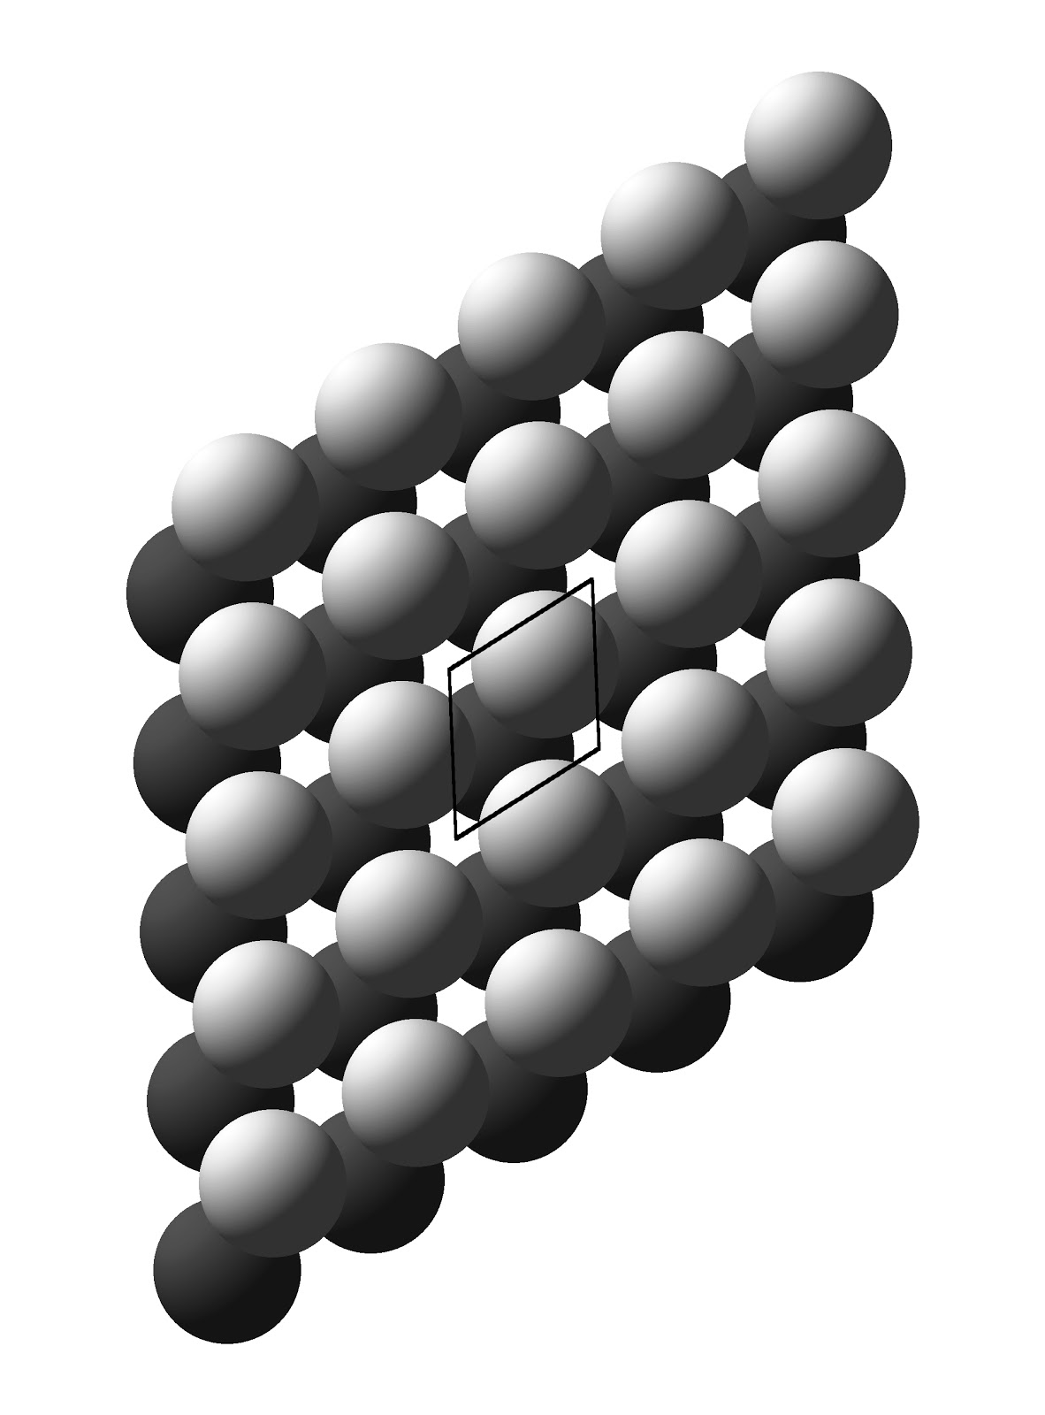Alternatively, what is the ratio of tetrahedral holes to octahedral holes in the close packed layers shown below?

(Be sure to count only holes that are *completely* coordinated by the lattice ions. There are CrystalMaker & StudioView files available for this problem.)

1. How many atoms of each type are present in a single unit cell for Wurtzite, NiAs, Rocksalt, and zinc blende? In each structure shown below, the sulfur anions are shown as yellow spheres and the cations, which could be either cobalt or manganese, are shown as light green spheres. Lastly, comment on the relative ratios of anions and cations in the structures shown below.

|  |  |
| --- | --- |
| Wurtzite | NiAs |
| C:\Users\emv19724\Documents\EVilla\IONiC VIPEr 2017 Teaching Conference\Articles\Images\Wurtzite.jpg | C:\Users\emv19724\Documents\EVilla\IONiC VIPEr 2017 Teaching Conference\Articles\Images\NiAs.jpg |
| **Rocksalt** | **Zincblende** |
| C:\Users\emv19724\Documents\EVilla\IONiC VIPEr 2017 Teaching Conference\Articles\Images\Rocksalt.jpg | C:\Users\emv19724\Documents\EVilla\IONiC VIPEr 2017 Teaching Conference\Articles\Images\Zincblende.jpg |