Synthesis and Characterization of a Series of Organometallic Ru(II) Complexes with Fluorinated Phosphine and Phosphite Ligands

Adapted from:
Synthetic, structural, and spectroscopic studies of mixed sandwich Ru(II) complexes involving η⁶-p-cymene with monodentate fluorine-containing phosphines or phosphites
J. Coord. Chem. 2016, 69, 20-38.
(DOI: 10.1080/00958972.2015.1114613)
Learning Goals:
After this laboratory experiment, students will be able to:

- Prepare a series of Ru(II) phosphine or phosphite complexes
- Characterize the complexes by
  - multi-nuclear NMR spectroscopy
  - UV-vis spectroscopy
  - Structural characterization (OPTIONAL):
    - If an X-ray diffractometer is available, grow crystals and solve the crystal structure
    - If X-ray crystallography is not available at your institution, the structural data is available for download to Mercury for viewing (see p. 4 for more details)
- Use physical characterization data to formulate trends in, for example, ³¹P NMR chemical shifts, Ru-P bond distances and electronic transitions with the amount of fluorine present in a series of fluorine containing-phosphine and -phosphite complexes
- Express conclusions using tables
- Write a full ACS journal style lab report
Related Literature:

- Serron, S. A. and Nolan, S. P. Organometallics 1995, 14, 4611-4616.
- Ozerov, O. V.; Fafard, C. M.; Hoffman, N. W. J. Chem. Ed. 2007, 84, 489-492.

Introduction:

The discovery of ferrocene and related metallocenes in the early 1950’s led to an explosion of interest in organometallic chemistry that continues to this day. This discovery showed that the π bonds in unsaturated hydrocarbons (such as the cyclopentadienyl anion) could form extremely strong links to transition metals. Because benzene is similar in many respects to the cyclopentadienyl anion (both are six-electron π systems), inorganic chemists became interested in whether benzene could also form complexes with transition metals. In 1955, the first such complex was described: the compound bis(benzene)chromium(0). As it turned out, compounds closely related to bis(benzene)chromium(0) had actually been prepared as early as 1919, but their structures had been incorrectly drawn.
Organometallic chemistry has had a dramatic impact in the field of catalysis, particularly in the field of synthetic organic chemistry where homogeneous organometallic complexes have been used to bring about transformations that in many cases cannot occur under typical laboratory conditions, and/or bring about selectivity in an organic reaction. In many homogeneous systems, determining the mechanism of a transformation is possible and critical to catalyst design. In order to make rational choices in complex design, an understanding of the coordination chemistry of a series of ligand can be useful.
In this experiment you will prepare a series of organometallic compounds of the type [Ru(p-cymene)(L)(Cl)₂] where L = P(C₆H₅F)₃, P(C₆H₅CF₃)₃, P(C₆H₃(CF₃)₂)₃ PPh₃, P(OCH₂CF₃)₃, P(OCH(CF₃)₂)₃ and POMe₃. These are metallocene related compounds and are commonly referred to as a piano stool compounds where the arene is the “seat” and the other three monodentate ligands (L and Cl x 2) are the “stands.” You will then characterize the compound by multi-nuclear NMR (¹H, ¹³C, ³¹P and ¹⁹F) and UV-vis spectroscopy. If available the compounds can be studied using single-crystal X-ray crystallography and computational methods.
Hazards and Disposal:

Dispose of all organic waste solutions in the Specially-Labeled Waste Containers. Do not pour organic solvents down the sinks.

Timeline:

Week 1 – Prepare assigned complex(es) and crystallize
Week 2 – NMR and UV-vis characterization
Week 3 – X-ray diffraction (optional) or use crystallographic data for viewing in Mercury

Procedure:

Part I: Prepare, isolate, and setup crystallizations for [Ru(p-cymene)(L)(Cl)₂]

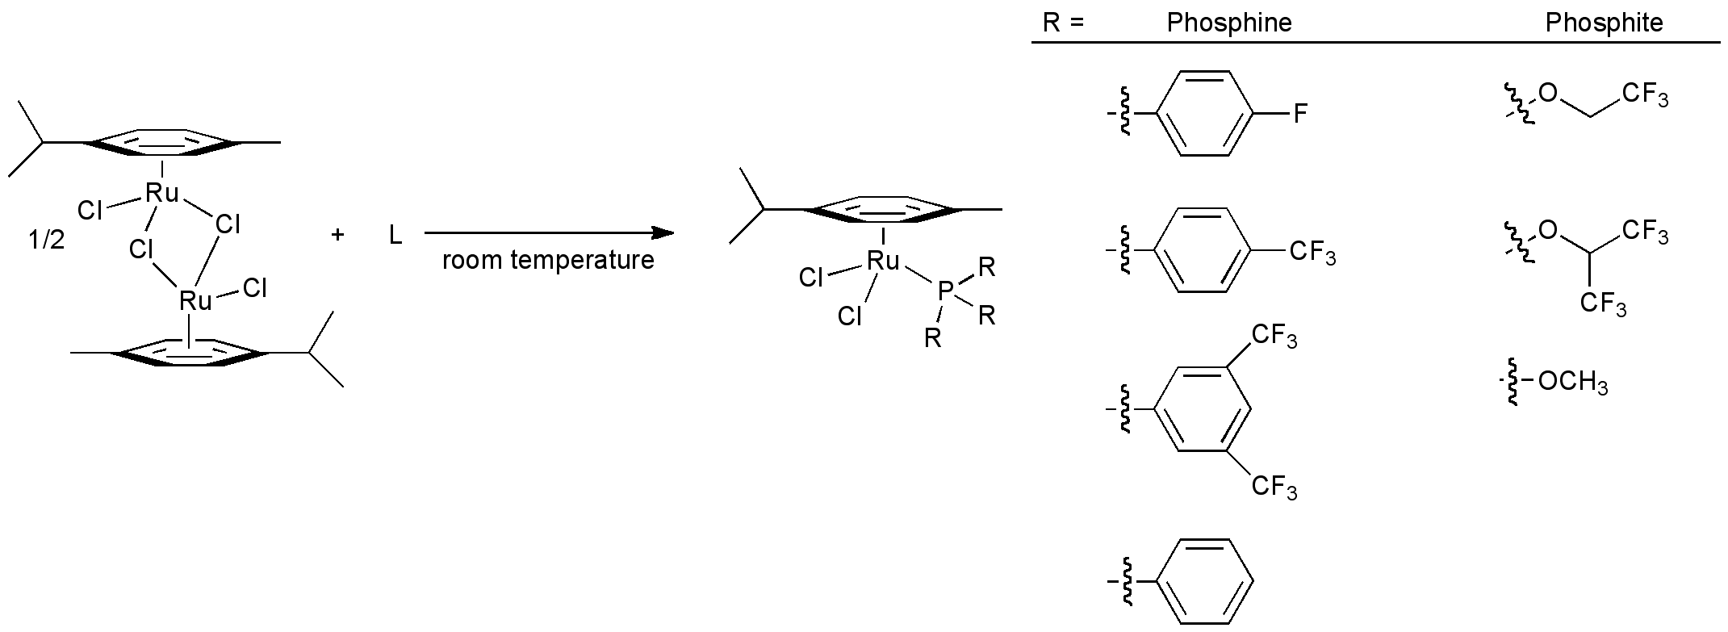
For illustrative purposes a procedure for the preparation of [Ru(p-cymene){P(C₆H₄-F-p)(Cl)₂] is given. This procedure can be extended to your assigned phosphine or phosphite.

Synthesis of [Ru(p-cymene){P(C₆H₄F-p)₃}(Cl)₂]
Week 1. Place 0.100 g (0.163 mmol) of [{(p-cymene)RuCl₂}₂] and 5 mL of 2-methyltetrahydrofuran in a 25 mL round bottom flask. To the stirring mixture add 0.106 g (0.335 mmol) of tris-(p-fluorophenyl)phosphine along with another 5 mL of 2-methyltetrahydrofuran. Allow it to stir at room temperature for 1 hour. Use this time to predict what you expect to see in the ¹H NMR.
When the reaction is complete, reduce the solvent volume in vacuo on a rotary evaporator to a minimal amount keeping the solid dissolved or until an oil is present. Add ice-cold hexanes (or pentane) to precipitate the product and collect by vacuum filtration using a 15-mL sintered glass funnel. Wash the collected product while on the frit with your ice-cold hydrocarbon (2 – 3 mL several times) and dry under vacuum. Calculate your % yield.

Characterization of [Ru(p-cymene){P(C₆H₄F-p)₃}(Cl)₂]
Week 2. You will characterize your complex by multi-nuclear NMR spectroscopy. For ¹H, ³¹P and ¹⁹F NMR you will only need 5 – 10 mg of sample dissolved in 0.7 mL of CDCl₃. A ¹³C NMR spectrum will either be supplied on Blackboard for your analysis or obtained overnight using the same sample. For UV-vis spectroscopy you will use dichloromethane as the solvent. A good starting concentration would be 10 mg in a 10 mL volumetric flask. Remember, these need to be quantitative measurements! Absorbance values should be between 0.1 – 1.8 Abs units for accurate measurements (may vary with spectrometer).

Additional Characterization of [Ru(p-cymene){P(C₆H₄F-p)₃}(Cl)₂]
Week 3 (optional material(s)).
X-ray Diffraction (a). If a single-crystal diffractometer is available, large single crystals of all complexes (except [Ru(p-cymene){P(C₆H₄CF₃-p)₃}(Cl)₂]) are readily obtained by layering a concentrated methylene chloride solution of the respective complex with either hexanes (even with the mixture of isomers this solvent consistently gives good morphology crystals). The data set can easily be solved and refined in the free GUI for structure solution and refinement, Olex2. X-ray Diffraction (b). If a single-crystal diffractometer is unavailable, data sets can be downloaded from the internet (using the directions below) and viewed in Mercury (from https://www.ccdc.cam.ac.uk/solutions/csd-system/components/mercury/) for solid-state structural comparisons.
To download the cif files go to: https://summary.ccdc.cam.ac.uk/structure-summary-form
You can search using the CCDC numbers for the complexes:
[Ru(p-cymene){P(C₆H₅F)₃}(Cl)₂]: 1050243
[Ru(p-cymene){P(C₆H₃(CF₃)₂)₃}(Cl)₂]: 1431544
[Ru(p-cymene){P(Ph)₃}(Cl)₂]: 627336
[Ru(p-cymene){P(OCH₂CF₃)₃}(Cl)₂]: 1050244
[Ru(p-cymene){P(OCH(CF₃)₂)₃}(Cl)₂]: 11050245
[Ru(p-cymene){P(OMe)₃}(Cl)₂]: 1050246

Part II. Post-lab Directions

Communicate your results and interpretations in the style of a paper to be published in Inorganic Chemistry, the flagship ACS journal in this field. Gather data from your classmates for each of the compounds in the reaction scheme. In order to acknowledge their contributions to your report, you will list them as coauthors, but put your name as first author. Give your report a catchy and informative title.

Your report should contain at least the following:
- Balanced chemical reaction for the preparation of your complex or the complexes in general.
- % yield for for your complex.
- Propose a likely mechanism for this ligand substitution reaction.
- Why didn’t anyone make [Ru(p-cymene){P(C₆F₅)₃}(Cl)₂]?
- Describe the bonding between the arene and the Ru using qualitative MO theory.
- Use crystallographic data for this series to comment on the general structure and draw comparisons between the Ru-P bond lengths. Search the literature for related compounds such as [Ru(p-cymene){P(R)₃}(Cl)₂] (R = Ph, -OC₆H_{5,} -C₆H₅, and -CH₃).
- Point group of [Ru(p-cymene){P(C₆H₄F-p)₃}(Cl)₂].
- NMR spectra assignment using the symmetry of the molecule, chemical shifts, integration and most salient coupling constants.
- UV-vis spectra assignment including peak assignments and interpretations.

Your report should include the following parts:
Abstract-- The abstract must be a brief summary of the principal idea behind the experiment. Writing a good abstract shows that you can summarize the key idea behind the experiment. It is usually easiest to write this last when preparing your report.
Introduction--The introduction should primarily speak to why you are studying this particular compound or reaction. This will require you to go into the chemical literature. You will be tempted to use Wikipedia, and that is ok, but just remember to only use it as a starting point if needed. A better starting point is the list of references at the end of each experiment. The last paragraph of the introduction should succinctly state what you found and are going to discuss in your results while relating it to the introduction.
Procedure--For synthetic experiments, you should mimic (as closely as you can) an experimental section from a peer-reviewed journal such as Inorganic Chemistry. This will include amounts of reactants (grams or mL and moles), reaction times, reaction conditions, how a product was recovered, percent yield and important characterization data. The characterization data should only state the data, it will be interpreted in the next section.

Results and Discussion--These two sections are often separated with results stating what was observed (observations that cannot be changed) in the results section and interpreted (open for discussion) in the discussion section. However, as you are learning to write scientifically the two sections can be combined if desired and will represent the bulk of your report. Whenever possible, presentation of data in tabular fashion is encouraged. Data should always have the correct units and significant figures. The interpretations section would include discussions and explanations for the data found in the experiment. This is the most difficult section of the report to write. This would include, but is not limited to, proposed mechanisms, explanation of spectra obtained (NMR, IR, UV-vis, etc…) and any other pertinent information found in the experiment. Use ChemDraw to draw compounds and reactions – A picture is worth a 1000 words! A good way to tackle this is to divide the experiment in parts. The first part should be the synthesis. Show the chemical reaction and discuss important aspects of the reaction (e.g., color change, gas evolution, % yield), which include classifying the reaction class(es) and giving a theoretical basis for the reaction. The next parts include taking one piece of characterization at a time and discussing in detail what you learned. Be careful here, discussing what you learned is not the same thing as stating a list of ppm values from an NMR spectrum (that can be read by anyone!), but interpreting the data and relating it to how it gives evidence of the structure and what you learned in your experiment.
Conclusions--The conclusions section should be no more than two paragraphs. It should both highlight the key points you found, and detail how your results support your introduction.
References--Your report should include citations to pertinent literature examples throughout (in particular in the introduction). Each citation should be consecutively numbered and listed in this section. See any article in Inorganic Chemistry or Journal of the American Chemical Society (ACS journals) for examples of ACS style citations.
Spectra--Attach all spectra for new compounds.

