The Structure and Color of Alums
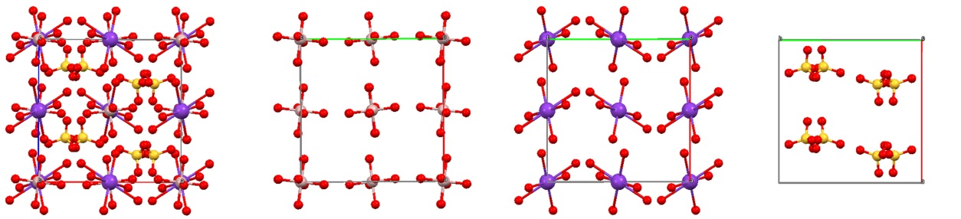
Alum is the common name for the hydrated salt of potassium aluminum sulfate. This is called a “double salt” because it contains two different cations - in this case, potassium and aluminum - that crystallize together in a single solid. The alum crystal structure shown below contains aluminum (gray) and potassium (purple) ions, as well as tetrahedral sulfate (SO₄²⁻) counterions. The crystal is a hydrate, and the red atoms shown attached to the metals indicate oxygens from the water molecules. (Hydrogens are not shown, for simplicity.) As indicated in the figure, the metal atoms have an octahedral coordination sphere, with a single metal ion surrounded by 6 water molecules. (The site symmetry of the potassium atoms is somewhat distorted from a true octahedron.) The formula for this compound is KAl[SO₄]₂*12H₂O. It is important to note that this compound is a salt, and so it fully dissolves into individual ions in solution. Here, the octahedral coordination of the metal ions depends on the crystal structure, unlike coordination compounds that maintain the same coordination geometry in the solid and solution states.
a
b
c
d
Figure 1. a) Crystal structure of KAl[SO₄]₂*12H₂O. (K = purple, Al = gray, S = yellow, O = red). Coordination spheres for b) Aluminum c) Potassium and d) Sulfur atoms. Box indicates unit cell axes.

It turns out that this particular crystal structure occurs in many compounds, which are described as isomorphous crystals because they share the same (iso) structure (morphos) despite having different compositions. The name “alum” is used to refer to the specific crystal shown in figure 1, but it is also used as the name of the family of compounds that have the same structure. We can write a general formula for the alum crystals in this way: $M_{A}^{I}M_{B}^{III}{[SO_{4}]}_{2}*12H_{2}O$, where $M_{A}^{I}$ is a metal with a +1 charge, and $M_{B}^{III}$ is a different metal with a +3 charge. The structure shown in figure 1 is the potassium alum, and if the aluminum ions were switched for chromium ions it would be called the chrome alum.
Isomorphous crystals are particularly interesting because they allow us to observe different metals within the same chemical environment. As long as the ionic radii are similar and the charges follow the pattern shown above, many different metals can be substituted into the same crystal structure:
$$M_{A}^{I}$$ | $$M_{B}^{III}$$
Potassium, rubidium, cesium, thallium, and even some polyatomic ions like ammonium, and methylammonium | Aluminum, gallium, indium, titanium, vanadium, chromium, manganese, iron, cobalt, rhodium, iridium
Each metal ion in an alum crystal has octahedral site symmetry, with 6 water molecules arranged around it. For each of the alums listed below, give the electron configuration for the metals. Do you expect these metal centers to be colored?
Formula | Electron configurations (of uncharged metal) | Colored?
KAl[SO₄]₂*12H₂O
KCr[SO₄]₂*12H₂O | K: Same as above | Same as above
KFe[SO₄]₂*12H₂O | K: Same as above | Same as above
CsCo[SO₄]₂*12H₂O

1) For each metal in the table, explain why you do (or don’t) expect it to be colored.

2) For each colored metal ion, draw the electron-filling diagram for the d-orbitals split by an octahedral crystal field. Indicate whether the electron configuration will tend to be high-spin, low-spin, or neither. (Keep in mind that water is low in the spectrochemical series, with a small Δ_{oct}.)

3) Predict the relative size of Δ_{oct} for alums made from Cr, Mn, Fe, and Co that are identical except for the $M_{B}^{III}$ ion. Rank the compounds from smallest to largest splitting.

4) Predict the relative size of Δ_{oct} for alums made from Co, Rh, Ir that are identical except for the $M_{B}^{III}$ ion. Rank the compounds from largest to smallest splitting.

5) Which of the series of alums from question 3 and 4 do you expect to show a bigger change in Δ_{oct}? Why?

6) Which metal center(s) do you expect to have the greatest chance of being low spin? High spin? Explain your reasoning.

Further resources:
Discussion of isomorphism and the effects of periodic trends on crystal field splitting:
Raynor-Canham, G.; Overton, T. Descriptive Inorganic Chemistry 6th Ed. W.H. Freeman and Co., New York City, NY, USA, 2014. pp 113-116, 530-536.
Downloadable crystal structure files (.cif format) for use with visualization software such as Crystal Maker or Mercury (CCDC):
http://www.crystallography.net/search.html
A web-based interactive model of the crystal structure is also available here:
http://crystals.otterbein.edu/gallery/alum.html
Related literature:
Schaffer, C. E.; Steenberg, P. The Cobalt Alums: A Demonstration Experiment. J. Chem. Educ., 2002, 79(8) 958
Fliedner, L. J. The Preparation and Preservation of Large Crystals of Chrome Alum. J. Chem. Educ., 1932, 9 (8), 1453
Morrow, S. I. One Hundred and Fifty Years of Isomorphism. J. Chem. Educ., 1969, 46 (9), 580

Structure plotted using Mercury software from the Cambridge Crystallographic Database. Structural information obtained from the Crystallography Open Database (COD #1011177) accessed on 6/30/2014. Structure originally published by: Beevers, C A; Lipson, H Crystal Structure of the Alums Nature (London) 134 (1934) 327-327.
Lambert, J.L.; Lambert M. W. The Alums: Interchangeable Elements in a Versatile Crystal Structure. J. Chem. Educ. 1970, 47(6), pp. 465-6.

