# Laboratory Experiment

# The Synthesis and Characterization of Cobalt Spinels

Solid state synthesis of cobalt spinels characterized by powder X-ray diffraction and UV-Vis diffuse reflectance spectroscopy

**Objective**

Students will use solid state techniques to synthesize four spinels (ZnCr2O4, ZnCo2O4, CoAl2O4 and CoCr2O4) and use X-ray diffraction and UV-Vis diffuse reflectance spectroscopy to characterize the structure and electronic transitions, respectively.

**Logistics**

The duration is two lab periods. Students will work in groups of two, each preparing two compounds, for a total of four. Students will write their own lab report, but should include the data for all four compounds.

**Introduction**

Solid state inorganic chemistry is a heavily researched field that has been largely driven by the potential for technological advances. Spinels are one type of solid state crystal structure and materials having this structure display a variety of properties. Magnetite, Fe3O4, is a naturally occurring magnetic ore and is used for many applications including magnetic recording. Other spinels have been studied for their magnetoresistant effects. LiMn2O4 has been used as a cathode material in lithium ion batteries. Spinels are also known for their bright colors in gemstones and pigments. The spinel cobalt blue is an inorganic pigment used to color ceramic, glass and paint.

*SPINELS*

The spinel structure, named for the mineral spinel MgAl2O4, consists of a cubic close-packed array of oxygen atoms. This packing leads to both octahedral and tetrahedral interstices. In a spinel unit cell ⅛ of the tetrahedral sites and ½ of the octahedral sites are occupied by cations. Figure 1.1 a shows the spinel structure. Figure 1.1 b and c show the cation tetrahedra and edge-sharing cation octahedra, respectively.

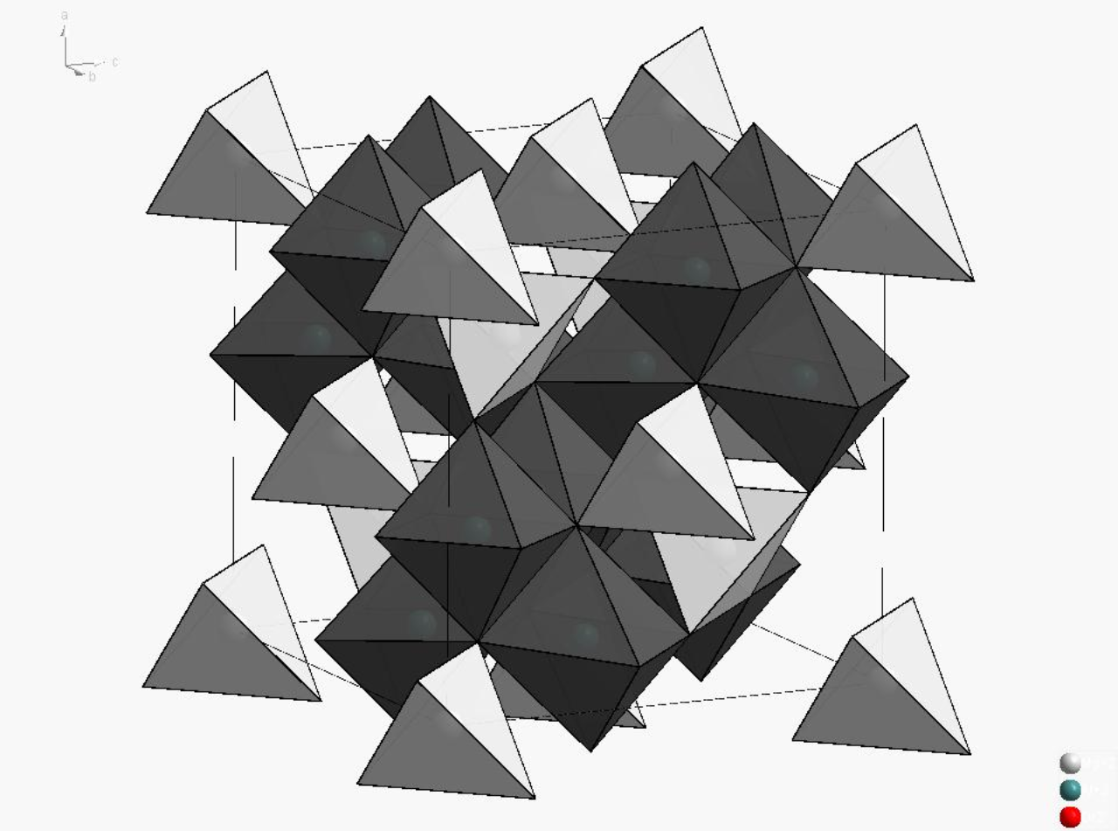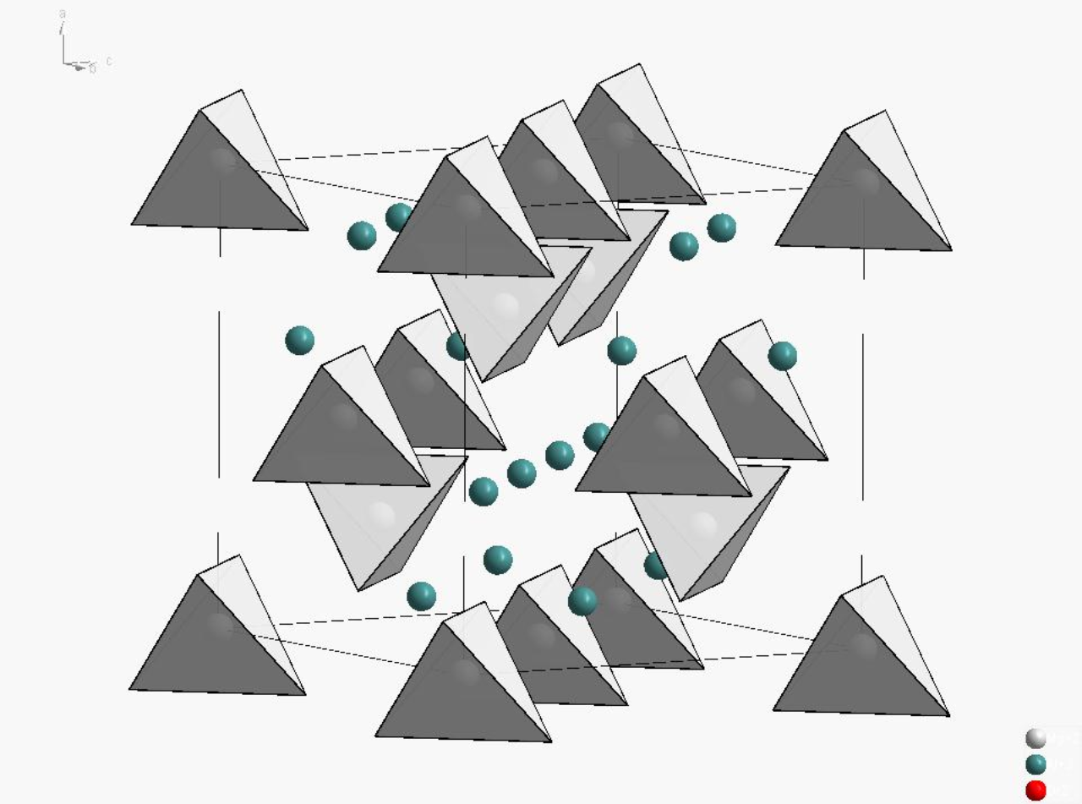 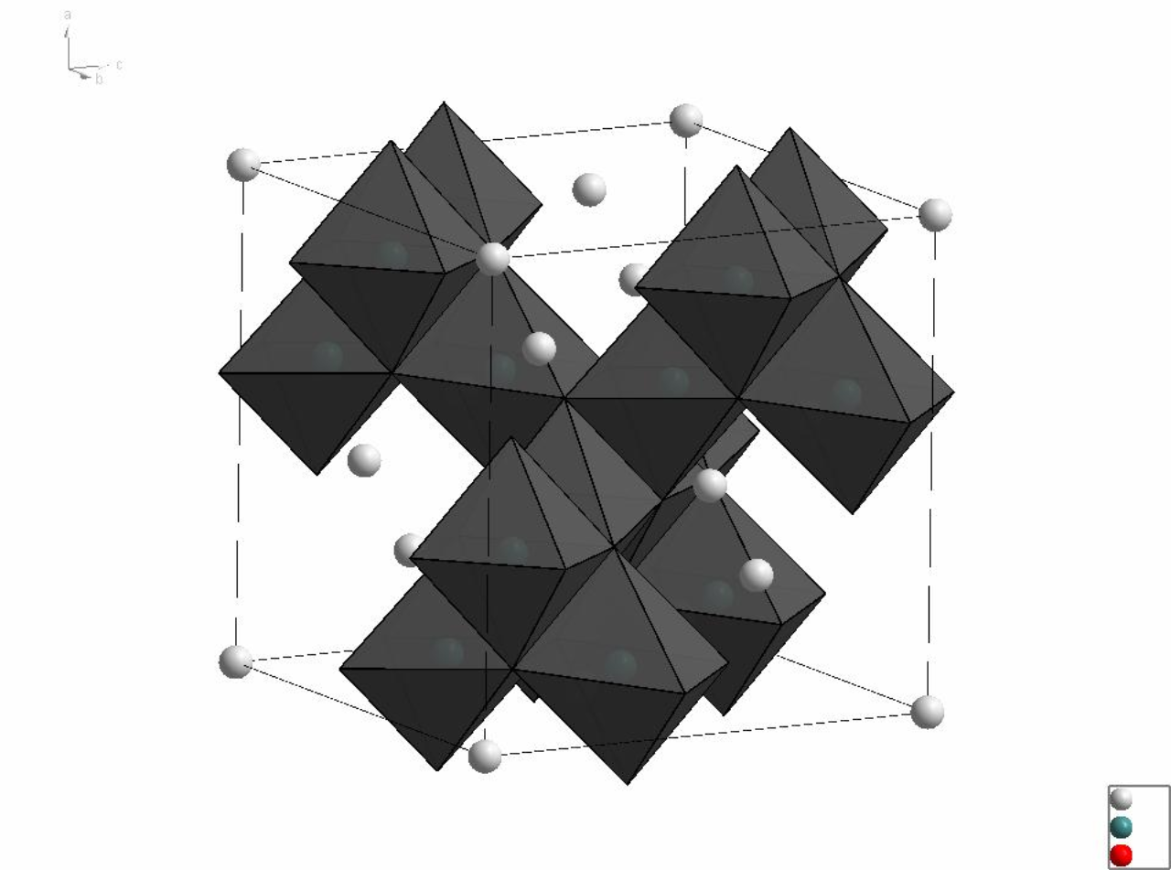

Figure 1.1 (a) left, Spinel crystal unit cell; (b) middle, spinel with the tetrahedra shown and (c) right, spinel with the octahedra shown.

There are twice as many octahedrally (Oh) coordinated ions as tetrahedral (Td) ones and the formula thought as Td[Oh]2O4. In a normal spinel, AB2O4, the tetrahedral sites are occupied by divalent ions (A) and the octahedral sites by trivalent ions (B). For an inverse spinel, B[AB]O4, the trivalent ion occupies all of the tetrahedral sites and ½ of the octahedral sites. The remaining ½ of the octahedral sites are occupied by the divalent ions. In addition, compounds may exhibit structures in between the spinel and inverse spinel structures. A factor, λ, is commonly used to indicate the degree of disorder with a λ = 0 for a normal spinel and a λ = ½ for an inverse spinel.

There are several factors that will affect which spinel structure (regular, inverse or intermediate) a material will take. The relative sizes of the A and B cation will play a role along with their charges. In general the smaller cation will prefer the site with the lower coordination, that is the tetrahedral site. This is not the only factor though, as we see in spinel MgAl2O4 the smaller Al3+ occupies the octahedral sites. Another factor affecting the spinel structure is the crystal-field stabilization energy (CFSE) of the metal ions. While CFSE is only a small percent of the overall energy stabilization, it can be a determining point in a structure if all other energy factors are relatively constant. To determine the preference, the CFSE of an ion in both the octahedral and tetrahedral geometry is determined and then compared. The difference between the two may be referred to as the octahedral site preference energy (OSPE). The cation, A2+ or B3+, with the larger OSPE will tend to occupy the octahedral site. That is, if A2+ has the larger OSPE it will preferentially occupy the octahedral site and the inverse spinel is favored. If B3+ has the larger OSPE, it will preferentially occupy the octahedral site and the regular spinel structure is favored.

*X-RAY DIFFRACTION*

*Supplemental information regarding XRD will be handed out in lecture*

While the structure of the spinel is somewhat complex it is important to note that all of the structural details are specified by only two parameters, the unit cell edge length, a, and the oxygen position in the unit cell, x. Spinels are cubic and their X-ray diffraction patterns may be used to determine a and x. The unit cell parameter, a, is related to the 2θ peak positions. The x parameter is related to position of the oxygen atoms in the unit cell and will impact the intensities of the diffraction peaks. For this lab, the XRD pattern will be indexed to find the a parameter.

Indexing is the process of using XRD peak positions to determine the unit cell dimensions. For cubic materials this can be very straightforward, as there is only one parameter, a. Other lower-symmetry crystal systems are more challenging to index and typically the use of computer algorithms is employed. Bragg’s Law (Equation 1.1) tells us the location of a peak with indices hkl, θhkl, is related to the d-spacing:

λ = 2 dhkl sin θhkl  (1.1)

The d-spacing is also related to hkl indices by Equation 1.2:

$\frac{1}{d^{2}}=\frac{h^{2 }+ k^{2 }+l^{2 }}{a^{2 }}$ (1.2)

By combining and rearranging these equations we may get

$\frac{\sin^{2}θ}{h^{2 }+ k^{2 }+l^{2 }}=\frac{λ^{2}}{4a^{2}}$ (1.3)

Using educated guessing we need to find values of h, k, and l that give a constant when each is divided by sin2θ. We may then use this to solve for the lattice parameter, a.

**Pre-Laboratory Questions**

*Submit answer on a separate sheet of paper at the beginning of the second lab period*

1. Write out balanced chemical equations for the synthesis of a spinel from the corresponding oxide reagents; ZnO, CoO, Al2O3 and Cr2O3. Calculate the mass of each reactant needed to make 2.00 grams of the product. Complete this for each of the four spinels: ZnCr2O4, ZnCo2O4, CoAl2O4 and CoCr2O4.
2. Fe3O4 crystallizes in an inverse spinel structure, with iron in two oxidations states. Use CFSE to reason why the inverse spinel structure is energetically favored. Rewrite the formula to explicitly resemble the inverse spinel formula (B[AB]O4).
3. Co3O4 crystallizes in a spinel structure with cobalt in two oxidations states. Use CFSE to reason why the spinel structure is energetically favored. Rewrite the formula to explicitly resemble the spinel formula (AB2O4).
4. The compounds you will make in lab, ZnCr2O4, ZnCo2O4, CoAl2O4 and CoCr2O4, are all normal spinel structures. Rationalize this form over the inverse spinel structure using CFSE.

**Materials Required**

**Equipment Chemicals Common equipment**

agate mortar and pestle ZnO analytical balance

weigh paper and spatula CoO high temperature furnace

crucibles Al2O3 Rigaku Miniflex Xray diffractometer

XRD sample holders Cr2O3 Ocean optics UV-Vis spectrometer

glass plate

**Procedure**

**Part A. Solid state synthesis**

*To be completed during the first laboratory period*

Working with a partner, four compounds will be synthesized. One person will synthesize these: ZnCr2O4 and ZnCo2O4, and the other person will synthesize these: CoAl2O4 and CoCr2O4. In solid state synthesis each reactant is a limiting reactant, and O2 may be a reactant or product. Use stoichiometric amounts of ZnO, CoO, Al2O3 and Cr2O3 to prepare 2.00 grams of each product. Weigh out the appropriate amounts and grind the reagents together in an agate mortar and pestle for at least 15 minutes. Transfer the samples to pre-weighed ceramic crucibles and attach a sticky label; heat in furnace to 1000 °C for 8 hours using 10 °C/min ramp rates. The label will be attached to outside of the furnace to note sample position. Weigh your sample after heating to find the percent yield.

**Part B. Characterization**

*To be completed during the second laboratory period*

Retrieve samples from furnace after heating and grind the product in an agate mortar and pestle. Prepare a diffraction slide of each compound. Transfer a finely ground sample to the XRD/reflectance sample holders and use the glass slide to obtain a smooth, flat surface. The sample height must not be higher than that of the sample holder else a significant shift of peaks will be observed. Collect diffraction data for each sample and analyze the patterns to index the sample. Scan the sample in the diffractometer from 10° − 80° 2θ using a scan speed of 15°/min for CoCr2O4 and ZnCr2O4 and a scan speed of 8°/min for ZnCo2O4 and CoAl2O4. Note: cobalt samples fluoresce and will have additional noise in the XRD scans. Obtain 2θ peak positions in the software program Jade and save the spectra. Using the same sample holder, collect UV-Vis diffuse reflectance data of each compound and use the data to characterize the electronic structure.

**Waste Disposal**

Leftover product should be saved in vials for further analysis in Experiment 3.

**Results**

* Include a copy of your diffraction patterns in your report.
* Using your diffraction pattern, locate the peaks and index the structure to determine the unit cell length for each compound.
  1. Note: Do this for 2 of the four compounds, with your lab partner.
  2. If you have XRD patterns that are “messy” use the software to search the database for phases.
* Include a copy of your UV-Vis spectra (All four on one graph is fine) and include the analysis in your report. Specifically related the spectra to the color observed.

**Discussion**

* Comment on the structure of the spinels, and if the synthesis was successful.
  + Did you make what you had intended to make? (Use software + database to determine this)
* Compare the unit cell parameters for each spinel relative to each other; do these make sense?
* From the indexed patterns, does the cubic cell have any lattice centering?
* What colors were the compounds? Does the UV-Vis reflectance data correspond to the color we see?

**References**

1. Rohrer, G. S. *Structure and bonding in crystalline materials*; Cambridge University Press, 2001, pg 162.

2. Huheey, J.E.; Keiter, E.A.; Keiter, R.L. *Inorganic Chemistry: Principles of Structure and Reactivity*, 4th ed.; HarperCollins: New York, 1993, pg 411.