Lab 5: The synthesis of 12-tungstosilicic acid ‡

INTRODUCTION

This week you will be synthesizing a polyoxometallate, which is an oxoanion that contains multiple metal atoms. As perhaps the simplest example of this, consider the formation of the dichromate ion from the condensation of two chromate ions in acidic solution. The acid protonates an oxygen of each chromate; condensation and elimination of a water molecule yields dichromate.

Since there are two chromium atoms, dichromate can be considered a polyoxometallate. These reactions are highly dependent upon pH and concentration, which dictate the exact product formed. The typical polyoxometallate, however, is a larger structure formed from multiple condensation reactions, such as [Mo₈O₂₆]⁴⁻.

Polyoxometallate formation is common for group 5 and 6 d-block elements. Many example exists based on V, Mo, and W. Mixed metal, or heteropolyoxometallates are also common, such as the 12-tungstosilicic acid that you will be synthesizing. In this compound, there is both silicon and tungsten present. The “12” in the name refers to the fact that there are 12 W atoms in the structure. This particular compound adopts the Keggin structure, so named after its founder. The general formula is [X^{n+}M₁₂O₄₀]^{(8-n)-} where X is the heteroatom and M is the main metal atom, Si and W, respectively in our case. The overall charge is dependent upon the identity of the heteroatom.

The equation for the synthesis reaction is

The tungsten and silicon precursors are heated to boiling and acid is added. Impurities are extracted and the product is crystallized from solution by evaporation.

In 12-tungstosilicate, the silicon heteroatom is surrounded by four oxygen atoms to form a tetrahedron. Likewise, each tungsten atom lies at the center of an octahedron of oxygen atoms. These octahedra are linked together by edge-sharing of oxygen atoms. The SiO₄ unit is located in the center of the structure and is surrounded by the 12 octahedral MO₆ units (Figure 1). The entire anion has tetrahedral (T_{d}) symmetry.

Interest in these types of compounds has been renewed due to their use as solid acid catalysts in selective oxidation reactions.

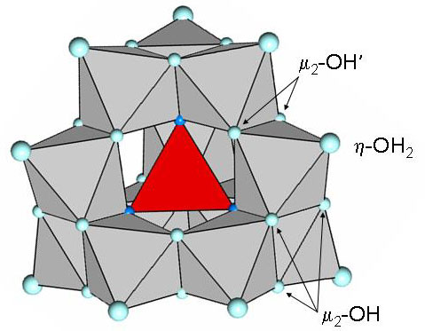
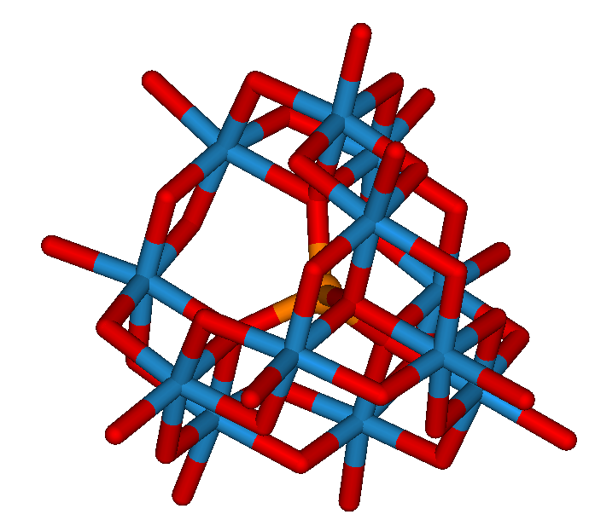

Figure 1. Two structural representations of the Keggin ion. On the left, the structure is shown in the polyhedral form in which the metals reside in the centers and and oxygen atoms are at vertices. The central tetrahedral SiO₄ unit is shaded red and is surrounded by 12 WO₆ octahedra. Note that oxygen atoms are shared along the edges of adjoining octahedra. (The notation shown corresponds to specific sites in the structure that do not necessarily apply here. The “2” in the “μ₂” indicates that the oxygen atom bridges two metal atoms.) On the right, the Keggin ion structure is represented in “stick” form. The silicon atom is shaded orange; the tungsten atoms are shown in blue and surround the central silicon.

WEEK ONE - SYNTHESIS

PROCEDURE

You will be working with concentrated hydrochloric acid during the experiment. Work carefully and wear proper protective gear, including gloves.

1. Dissolve 12.5 g sodium tungstate dihydrate, Na₂WO₄·2H₂O, in 25 mL water in a 100 mL round bottom flask by stirring on a stir/hot plate. Once dissolved, remove from the plate and then add 1 g sodium silicate solution (by transfer pipet).

2. Return the flask to the heating mantle. Add 7.5 mL concentrated HCl to a dropping funnel (be sure that the valve is closed!) and insert the funnel into the opening of the round bottom flask. Heat the contents of the flask to just boiling under vigorous stirring.

3. Once the contents are gently boiling, add the acid to the solution, dropwise, over a period of 10 minutes. Record what happens during this process.

Assuming that 1 mL ≈ 20 drops, 7.5 mL is 150 drops; to dispense over 10 minutes, set the dropping rate to about 1 drop every 4 or 5 seconds.

4. Remove the apparatus from the heat and allow it to cool to ambient temperature. Vacuum filter the solution into a clean flask to remove any solid impurities and save the filtrate.

5. Transfer the reserved filtrate to a 125 mL separatory funnel. Add 5 mL more concentrated HCl and 10 mL ether. Gently shake the sep funnel and vent frequently. Three liquid phases should form. If not, add more ether.

6. Collect the bottom layer into a small beaker and discard the other two layers. Rinse out the sep funnel with water.

7. Return the reserved liquid in the beaker to the sep funnel. Add a solution of 3 mL concentrated HCl in 10 mL water, followed by 2.5 mL ether. Shake the funnel and again reserve the lower layer, transferring it into an evaporating dish.

8. Place the evaporating dish in a hood and let it stand for two days to remove the solvent and crystallize the product.

9. After two days, transfer the evaporating dish to an oven and dry the newly formed crystals at 70 °C for 2 hr.

Your instructor will do this, but you may wish to take a look at the product before it goes into the oven.

WEEK TWO - CHARACTERIZATION

INTRODUCTION

Last week, you synthesized the compound H₄SiW₁₂O₄₀ · xH₂O. In addition to its classification as a polyoxometallate, it is also both an acid and a hydrate. This week you will be analyzing the compound by titration and TGA to determine the number of waters of hydration present. You will titrate the sample with 0.1 M NaOH which will provide an endpoint volume for one equivalent of acid. Because it is tetraprotic, you will need to multiply by four in order to determine the molecular weight of the acid. From the molecular weight, you can then derive the number of water molecules present. Separately, TGA will be employed to also determine the number of waters of hydration.

PRELAB ASSIGNMENT

First, look up the color change expected upon reaching the endpoint of the titration when using the indicator methyl orange. Second, calculate the molecular weight of the anhydrous acid.

PROCEDURE

Titration
1. Using a glass rod, gently break up the dried mass of product in the crystallization dish. Weigh the product and record its mass in your notebook. If you have less than 6 g of product, please consult with your instructor before proceeding.

2. Using an analytical balance, weigh out a 2 g sample of your product into a 125 mL Erlenmeyer flask. Record the exact mass transferred.

3. Add 50 mL of deionized water to the flask and swirl to dissolve the sample. Add 2-3 drops of methyl orange indicator. Titrate the acid to its endpoint with the standardized ~0.1 M NaOH and record the volume of titrant dispensed. Work carefully since the endpoint volume is entirely unknown to you.

Be sure to record the exact concentration (and associated uncertainty) of the titrant in your notebook. You will need these values for the calculation of the MW of the acid and its uncertainty.

4. Repeat steps 2 and 3 for two (2) additional acid samples.

5. Recall your analytical skills and calculate the average and relative standard deviation (rsd) of the ratio of the mass of acid to the volume of titrant values. Ideally, the rsd will be less than 0.2%. However, you likely will not have enough acid to perform additional trials to improve your statistics. Therefore, it is worth your effort to work carefully.

TGA
6. TGA data of the acid dehydration will be provided to you via OnCourse.

CALCULATIONS / DATA WORK-UP

In Excel, create an annotated spreadsheet for the titration data and statistical analysis. Calculate the molar mass of the acid and its standard deviation. An evil reminder: You must propagate the uncertainties in the titration and concentration of NaOH in order to obtain the standard deviation of the molar mass of the acid. Based on the titration results, what is/are the likely number of waters of hydration (“x” in the formula) to the nearest half-integer value? Consider the uncertainty in molar mass (the range) when determining the number of waters of hydration.

Download the TGA data and construct a profile (a plot of % mass vs. temperature) for the 12-tungstosilicic acid sample. Determine the % mass lost due to water based on the TGA profile by comparing the initial % mass (100 %) with the % mass at 300 °C. What number of waters of hydration, again to the nearest half-integer, is consistent with this loss?

REPORT
Due in lab the week of April 5.

Address the following items in a results and discussion section in your notebook. Attach printouts of the spreadsheet and TGA profile to your notebook photocopies.

1. Briefly recap what was done in this experiment.

2. Describe the structure of 12-tungstosilicic acid. How many structurally different kinds of oxygen atoms are there in the basic (deprotonated) 12-tungstosilicate anion, excluding waters of hydration? How many are there of each kind? Hint: Think about how the oxygen positions are related by the symmetry elements present in the molecule.

3. State the number of waters of hydration as determined by each method. Do the results of the titration and the TGA agree (no statistical analysis required)? If not, which do you believe to be more reliable? Why?

4. Now that you have a value for “x” in the formula of the product, calculate the % yield for your synthesis.

‡ The experimental procedure has been adapted from an experiment in The Synthesis and Characterization of Inorganic Compounds, by William L. Jolly, 1991, Waveland Press, Inc.

