**Viewing Jmol Images that call a Java applet:**

Recently it has become difficult to see images scripted with Jmol (the “straight up” version of Jmol that calls on a Java applet) because Java encountered some security breaches last year (2013). The browsers I have tested; Firefox and Safari on Mac and Firefox and Internet Explorer on Windows machines block web pages that call Java applets. Although Java has been updated (Java 7 update 51) to address the most recent security breaches, the browsers still block web pages that call a Java applet from loading. **Note that this also applies to our use of WebMO (at least at Carleton)**.

If pages are written to use JSmol (a javascript version of Jmol that does **not** call a Java applet to load) these pages are seen without any special machinations and can also therefore be seen on non-applet platforms. For a description of JSmol see <http://sourceforge.net/projects/jsmol/>. According to the description of JSmol by SourceForge, images created with JSmol can be seen on iPhone/iPad and Android platforms as well. I note that in the future, I will both write my new pages in JSmol and begin to convert my older web pages to JSmol. Many people have already moved from Jmol to JSmol

In the meantime, to be able to use Jmol images (images/visualizations/animations) written to call a Jmol applet: This is what works as of today March 14, 2014 and is subject to change as Java and browers update. If you need a test case you can try one of my web pages: <http://www.people.carleton.edu/~mcass/1-Inorganic-C351/MCH36C.html>

**This is what you will see if you try to open a page that calls a Java Applet:**



**To Override the Block:**

**For a Mac:** **(For Windows See the Bottom of Page 3)**

Go to System Preferences (under the Apple Menu): You should find a Java icon: See line 5, 4th icon from left below: Click on the Java icon



When the Java Control Panel Opens, go to the Security Tab (at the top)



Here you can either use the sliding bar to lower the Security Level (which some people do evidently successfully and without concern) **Or:** Edit the Site List for “Exception Site List” which I do. I add sites I want, including my own. If you notice, I have not included the full URL, truncating after the mcass/ so that I can see all pages within that folder and am not limited to a single URL. Also I note that Carleton’s ITS team suggested I include my site both with the www and without. Click OK.

I can now see my images in both Firefox or Safari Browsers (note Chrome will not work). When my pages come up, (be patient, particularly for the 1st web page opened), I see the following “Security Warning”. Browsers are scripted to alert you to the fact that you are asking to open a java applet.



Click Run and wait for the images to load.

As a final note; My Safari Browser will now allow my Jmol commands to work. Firefox will also allow my commands to work but will give the following message when I click on any command for the first time after I have loaded the website.



I click OK and everything runs smoothly from there.

**For a Windows System** (Windows 7 and higher) the protocol is much the same.

I have tested this only on Firefox Internet Explorer (Chrome will not work).

Find Java in your programs lists (under the Window Icon in the bottom left corner) or just type in “Java” in your search programs and files bar. When you select Java, a window will open with a few options. Click on “Configure Java”. Then select the Security tab at the top and the following Window opens:

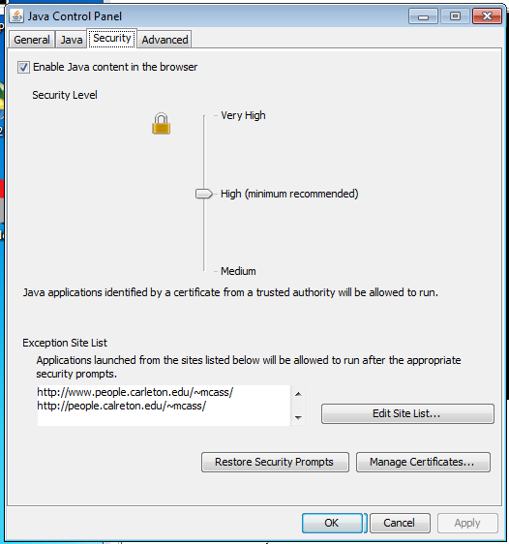

Here you can either use the sliding bar to lower the Security Level (which some people do evidently successfully and without concern) **Or:** Edit the Site List for “Exception Site List” which I do. I add sites I want, including my own. If you notice, I have not included the full URL, truncating after the mcass/ so that I can see all pages within that folder and am not limited to a single URL. Also I note that Carleton’s ITS team suggested I include my site both with the www and without. Click OK.

.

When you return and reload your selected Web page you will be asked: **Do you want to Run this Application?** Click Run and the images should load and the buttons and tools will work (be patient with loading of the first page in particular).