Chemistry 270 – Inorganic Chemistry I Group Members_________________, _________________

Structure, structure and more structure

_________________, _________________

**Part I. the primitive cubic / simple cubic structure**

1. Look at the two views of the simple cubic cell – **sc1** and **sc2**. What do you notice about the structure? Describe it in your own words.
2. How does structure **sc1** differ from structure **sc2** (simple cubic - first view - ball and stick)?
3. In **sc3**, how does the yellow cell differ from the pink cell?
4. A single unit cell is drawn in **sc4**. Draw a plan diagram for a primitive cubic cell.
5. How many total atoms are in a primitive unit cell? Show your work. Remember that each atom may not be completely in a singe unit cell.
6. What's the coordination number of each atom (e.g. how many other nearest neighbor atoms are touching it)?

**Part II. the body centered cubic (bcc) structure**

1. Open **bcc1**. What is the coordination number (number of nearest neighbors) of the atom in the center of the unit cell?
2. What's the coordination number (number of nearest neighbors) of an atom at the corner of the unit cell in **bcc1**? It may help you to look at several unit cells in **bcc2a**. In **bcc2b**, atoms in the center of the unit cell and the corners of the unit cell have been given different colors even though they are the same atom.
3. Draw the plan diagram for a bcc cell.
4. How many total atoms are in the bcc unit cell? Show your work. Remember that each atom may not be completely in a singe unit cell.
5. Compare and contrast the bcc structure and the primitive cubic / simple cubic structure?

**Similarities Differences a**

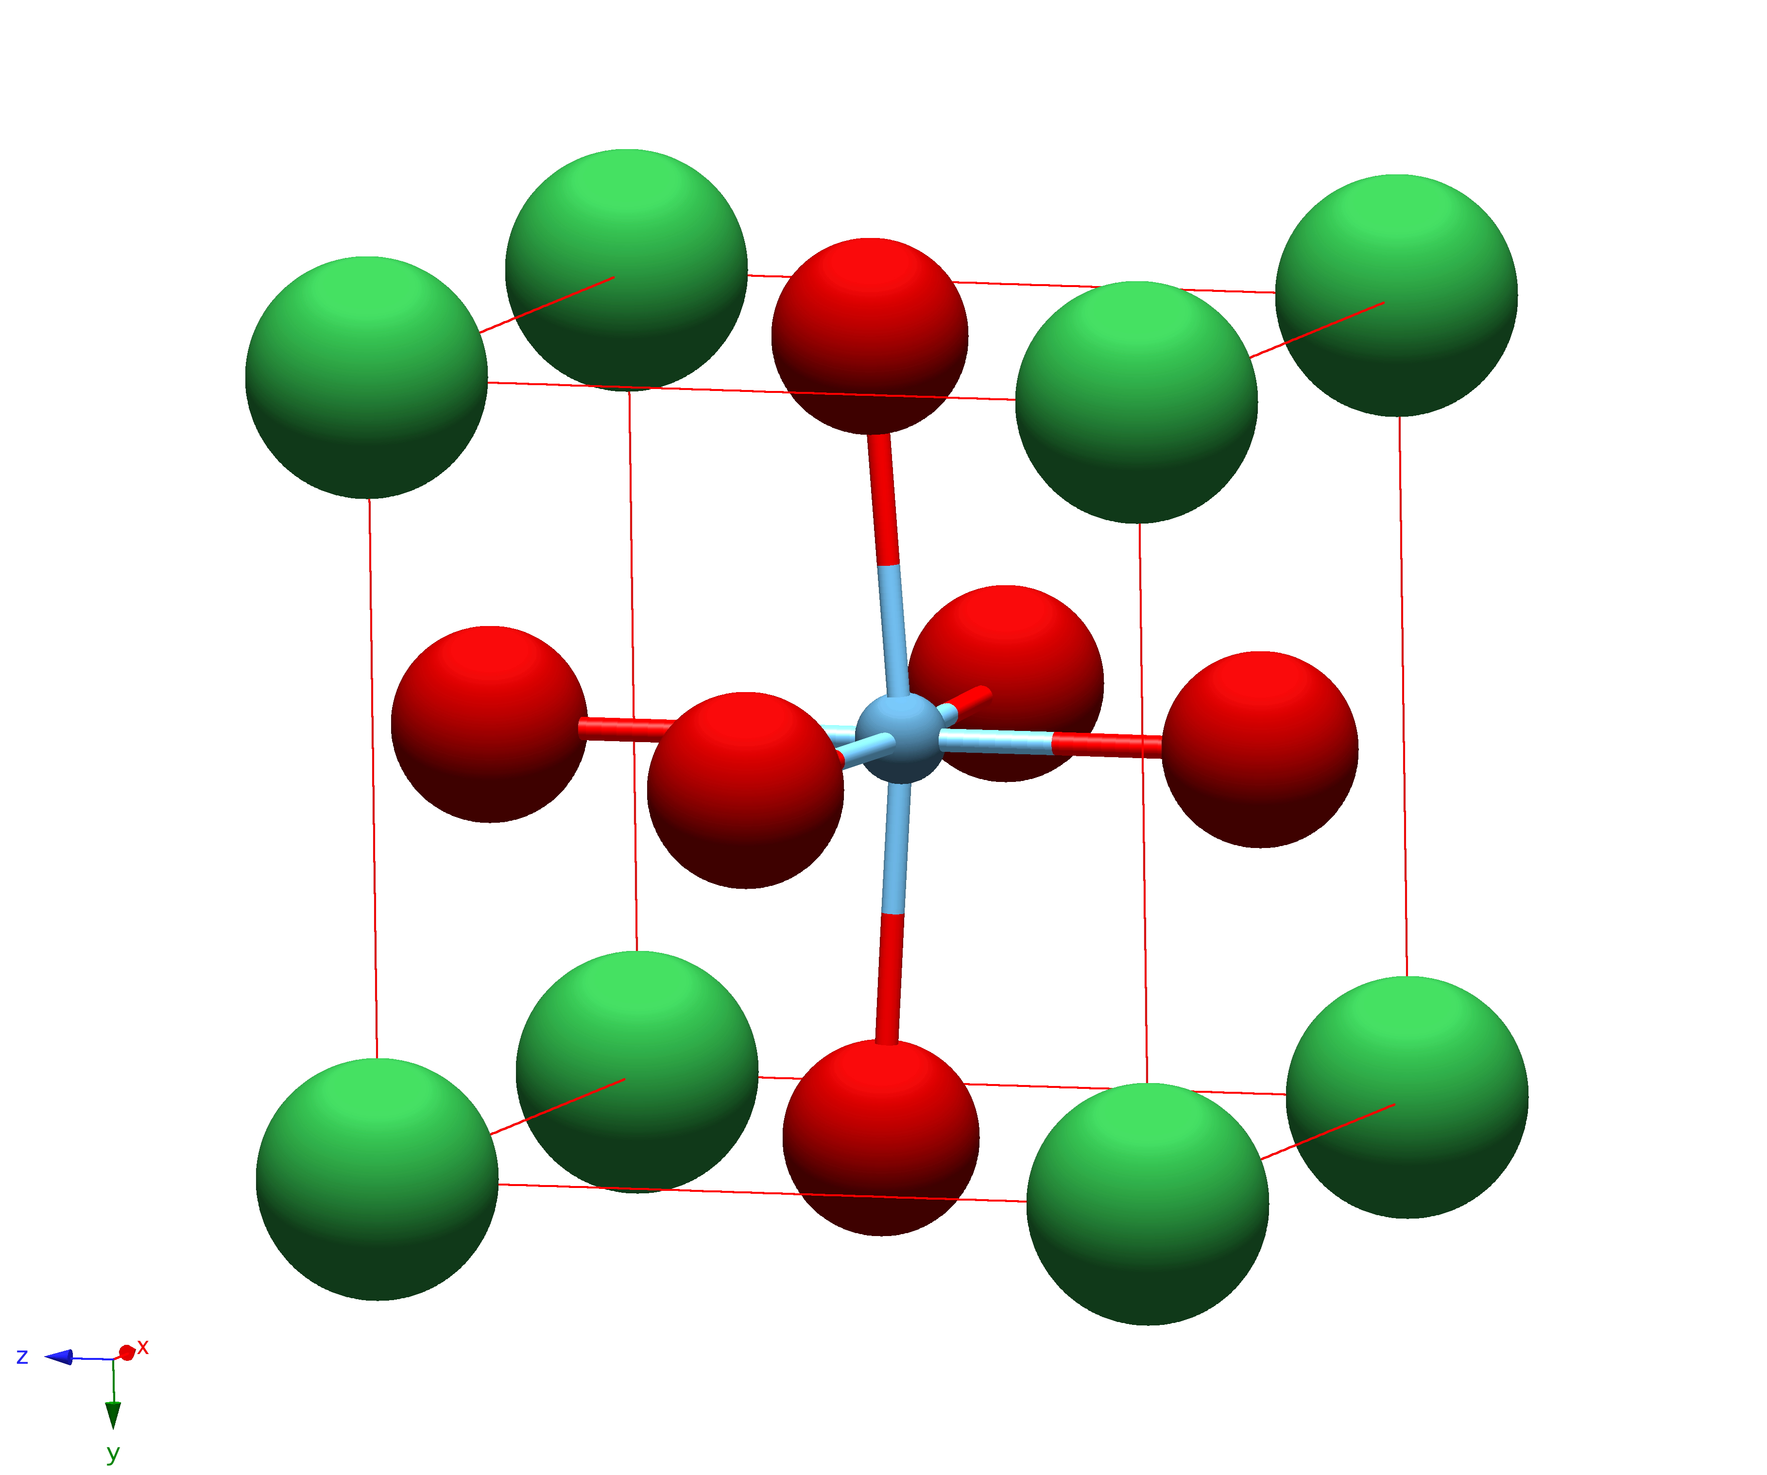**Part III. The cell**

1. Consider the unit cell shown (**perovskite**).
   1. How many of each atom are in a single unit cell?  
        
      corner (green):  
        
      face (red):  
        
      contained (blue):
   2. What is the empirical formula of the compound? Red atoms are   
      oxygen, blue atoms are titanium, green atoms are barium.

**Part IV. the hexagonal close packed (hcp) and cubic close packed (ccp) structures**

Find a partner team.

* Team A builds the hcp structure (p. 24).
* Team B builds the ccp structure (p. 25)

After building the models from the solid state model kit, each team should open the hcp (**hcp1**/**hcp2**) and ccp (**ccp1**/**ccp2**) structures in Studio Viewer. Read through the questions to guide your thinking. Compare the actual and virtual models. Then swap models with the other team, look at the models, and complete the questions.

1. What is the (nearest neighbor) coordination number of each atom?  
     
   hcp: in a layer = layer above = layer below = **total =**

ccp: in a layer = layer above = layer below = **total =**

1. What is the layer repeat structure (e.g. AAA means all layers on top of each other)?  
     
   hcp = ccp =
2. How are the hcp and ccp structures similar?
3. How are these hcp and ccp structures different?
4. Look at a single unit cell of the ccp structure (**ccp3**) using Studio Viewer. Explain why a ccp cell is also known as fcc (face centered cubic).
5. What do the different color spheres represent in the fcc cell (**ccp3**)?

**Part V. holes in the ccp structure - halite (NaCl)**

Work with your partner team.

* Team A builds the NaCl structure (p. 33)
* Team B builds the NaCl structure along the body diagonal (p. 32)

Everyone should open the halite structures (**halite1**) in Studio Viewer. Read through the questions to guide your thinking. Compare the actual and virtual models. Then swap models with the other team, look at the models, and complete the questions.

1. Which ion would you expect to be larger, sodium ion or chloride ion? Write your predictions and then look up the radii for each ion? (Hint: What definition of radius should you use? There are multiple radii found on WebElements. Which should you choose and why?)
2. In your model, do the large or small spheres represent sodium ions or chloride ions? How did you make your decision?
3. Open a single NaCl unit cell in Studio Viewer (**halite2**). How many ions of each type are in the unit cell? Show your work.

sodium ion = chloride ion =

1. In ionic solids, we talk about coordination number as the number of ion of opposite charge touching the ion (that we're looking at). What's the coordination of each ion? (You may find it useful to look at a structure with more than one unit cell.)

sodium ion = chloride ion =

1. An ionic solid can be described by the packing of the largest ion - simple cubic or close packed (hcp or ccp). How would you describe the packing of the larger ion in halite?
2. The positions of the other ions are described by how the smaller ions fill the empty spaces (holes or interstitials) in the structure - do they occupy octahedral, tetrahedral or cubic holes. What type of holes do the smaller ions occupy in the halite?
3. We also talk about the percentage of the holes that are filled in a structure. In close packed lattices, there is 1 octahedral hole per every lattice atom (1 Oh : 1 X) and 2 tetrahedral holes per every lattice atom (2 Td : 1 X). In halite, only one of these types of holes is filled.

What type of hole is filled?

What % of the __________ holes are filled? (Solve this both by the method of stoichiometric ratios and by inspection of the structure.)

**Part VI. more holes in the ccp structure - zinc blende**

Work with your partner team.

* Team A builds several unit cells of the zinc blende structure (p. 49)
* Team B builds the body diagonal view of the zinc blende structure (p. 50)

Everyone should open the zinc blende structures (**blende1**) in Studio Viewer. Read through the questions to guide your thinking. Compare the actual and virtual models. Then swap models with the other team, look at the models, and complete the questions.

1. Which ion would you expect to be larger, zinc(II) ion or sulfide ion? Write your predictions and then look up the radii for each ion? (Hint: What definition of radius should you use? There are multiple radii found on WebElements. Which should you choose and why?)
2. In your model, do the large or small spheres represent zinc(II) ions or sulfide ions? How did you make your decision?
3. Open a single ZnS unit cell in Studio Viewer (**blende2**). How many ions of each type are in the unit cell? Show your work.

zinc(II) ion = sulfide ion =

1. What's the coordination of each ion? (You may find it useful to look at a structure with more than one unit cell.)

zinc(II) ion = sulfide ion =

1. How would you describe the packing of the larger ion in zinc blende?
2. What type of holes do the smaller ions occupy in the zinc blende?
3. In zinc blende, only one type of hole is filled.

What type of hole is filled?

What % of the __________ holes are filled? (Solve this both by the method of stoichiometric ratios and by inspection of the structure.)

**Part VII. holes in the cubic structure – cesium chloride**

Build the primitive (simple) cubic structure (p. 9) and the cesium chloride structure (p. 11). Everyone should open the simple cubic (**sc1**) and cesium chloride (**CsCl_1**) structures in Studio Viewer

1. Which ion would you expect to be larger, cesium ion or chloride ion? Write your predictions and then look up the radii for each ion?
2. Which ion do the large spheres represent? How did you decide?
3. Open a single cesium chloride unit cell in Studio Viewer (**CsCl_2**). How many ions of each type are in the unit cell? Show your work.

cesium ion = chloride ion =

1. How does the cesium chloride structure compare to a primitive cubic structure? a bcc structure?
2. How would you describe packing in this type of structure?
3. In a simple cubic lattice, there is 1 cubic hole per every lattice atom (1 cubic : 1 X). In cesium chloride, what percentage of the cubic holes are filled? (Solve this both by the method of stoichiometric ratios and by inspection of the structure.)