Artificial Photosynthesis using Quantum Dot / Porphyrin Aggregates

Read the following article:

Lian, S.; Kodaimati, M. S.; Weiss, E. A. “Photocatalytically Active Superstructures of
Quantum Dots and Iron Porphyrins for Reduction of CO₂ to CO in Water” ACS Nano 2018, 12, 568-575.

1. This article focuses on catalyzing a particular reaction.

(a) Balance the reaction below by adding O₂ and coefficients as needed.

CO₂ → CO + ½ O₂

(b) Which element is oxidized in this reaction, and which is reduced? State the initial and final oxidation numbers for each.

(c) Where in nature does this same general type of reaction take place on a large scale?

(d) Outline the steps shown in the article’s Table of Contents graphic.

2. When the CuInS₂ / ZnS core / shell quantum dots are synthesized, they are only soluble in organic solvents. To make them soluble in water, their capping agent is changed.

(a) Draw the structure of the original capping agent. Hint: An “oleate” is the anion form of oleic acid, which is a long-chain carboxylic acid with the formula C₁₈H₃₄O₂ and one double bond between carbons 9 and 10.

(b) Draw the structure of the new capping agent. Which end coordinates to the surface of the quantum dot, and which end is presented into solution?

3. The very basic porphyrin structure is shown below.

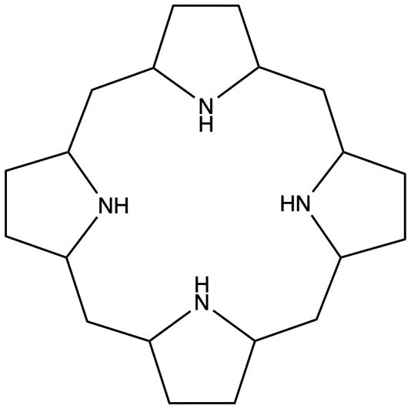

(a) Consult Figure 2C to help you add to this structure until you have achieved the FeTMA catalyst structure. You may have to delete some hydrogens and replace them with lone pairs of electrons.

(b) Which part of your completed structure corresponds to each part of the FeTMA name? FeTMA refers to:

trimethylamino-functionalized iron tetraphenylporphyrin.

(c) Considering the charge on the iron, the charges on the trimethylamino groups, and the charges on the coordinating nitrogens, what do you predict the overall charge on the FeTMA to be?

4. Why are these called “electron-funneling superstructures”? What is the new advance in this article?

