Synthesis of Zinc Oxide Nanoparticles

Nanoparticles are bits of matter with dimensions in the range of 1 to 100 nm (1 nm = 1 x 10⁻⁹ m). Synthesis and characterization of nanoparticles is an extremely active area of chemical research that has led to preparation of microscopic particles of single elements (e.g. Au or Cu), simple compounds (e.g. CdS or SiO₂) and even complex organic polymers such as poly-lactic acid. Thousands of papers on nanoparticle synthesis have been published in the chemical literature in the last several years, and a large number of patents and start-up companies have nanoparticle applications as their basis.
Most of the elements and compounds which have been made in nanoparticle form also have more common bulk forms in which particle sizes are 1 μm (1 μm = 1 x 10⁻⁶ m) or greater. One of the reasons for the great fascination with nanoparticles is that they often exhibit properties that are not found in these bulk analogues. For example, bulk gold metal has the shiny yellow appearance with which we are familiar, but solutions of gold nanoparticles are deep red or purple. In fact, nanoparticles very frequently have different optical absorption and emission behaviors than their bulk counterparts, leading to interest in their use in solar cells and next-generation video displays.
Zinc oxide (ZnO) is an inorganic, semiconducting material that shares its structure with ZnS (wurtzite). ZnO nanoparticles have attracted interest in part because of their optical properties. These particles are transparent to visible light, making them invisible to the eye, but they absorb ultraviolet light. One application of this material is therefore in UV-blocking coatings, including cosmetics and sunscreens. ZnO nanoparticles can be synthesized using a straightforward procedure with benign solvents such as water and alcohols. In this experiment, you will synthesize nanocrystalline ZnO and characterize it using powder X-ray diffraction.
Zinc oxide can be synthesized through the reaction of zinc acetate and lithium hydroxide in an alcohol:

Zn²⁺_{(alc)} + 2 CH₃COO–_{(alc)} + Li⁺_{(alc)} + OH–_{(alc)} → ZnO_{(alc)} + CH₃COOH_{(alc)} + Li⁺_{(alc)} + CH₃COO–_{(alc)}

This reaction proceeds through formation of an intermediate, or precursor, of the form Zn_{x}(CH₃COO)_{y}O_{z}. The exact composition of this species is still unknown. This intermediate forms when the reagents are mixed at 0ºC and is converted to ZnO as the mixture is warmed to room temperature. The resulting mixture is not a solution of solvated ions, but is instead a suspension of nanoparticles referred to as a colloid or sol. Water does not have the same ability to suspend the ZnO nanoparticles as alcohols. Thus, when water is added to the reaction mixture the particles are no longer suspended, but form aggregates that fall out of the mixture as a solid. This solid can be isolated and studied using powder X-ray diffraction.
Powder X-ray diffraction will provide two pieces of information about your nanoparticle sample. First, a diffraction pattern serves as a “fingerprint” for a given crystalline compound. Comparison of the positions of peaks in your pattern with those in a reference pattern (shown on the next page) will verify that ZnO has indeed been synthesized. There may be slight differences in the angles of your diffraction peaks and those in the reference pattern. These differences originate from factors in instrument alignment and sample preparation. Secondly, a powder X-ray diffraction pattern allows approximation of particle or crystallite sizes in a sample. In contrast with the reference pattern above, each peak in an experimental diffraction pattern has a measurable width. The peak width depends on several factors, including properties of both the instrument and the sample. For samples containing particles less than 1 μm in diameter, the most important of these factors is the particle or crystallite size. As the particle size decreases, the peak width increases. This reciprocal relationship is shown quantitatively in the Debye-Scherrer equation:

where D is the average particle diameter, λ is the X-ray wavelength (1.5418 Å for our instrument), β is the full width at half maximum (in radians) for a given diffraction peak and θ is the angle corresponding to the peak. Using this equation, it will be possible for you to estimate the size of nanoparticles in your synthesized sample.
This experiment will take place over two weeks. During the first week, you should prepare a sol containing ZnO nanoparticles and then precipitate and collect the nanoparticles in solid form. The sample will be dried during the week, allowing you to collect a powder X-ray diffraction pattern during the second lab period.

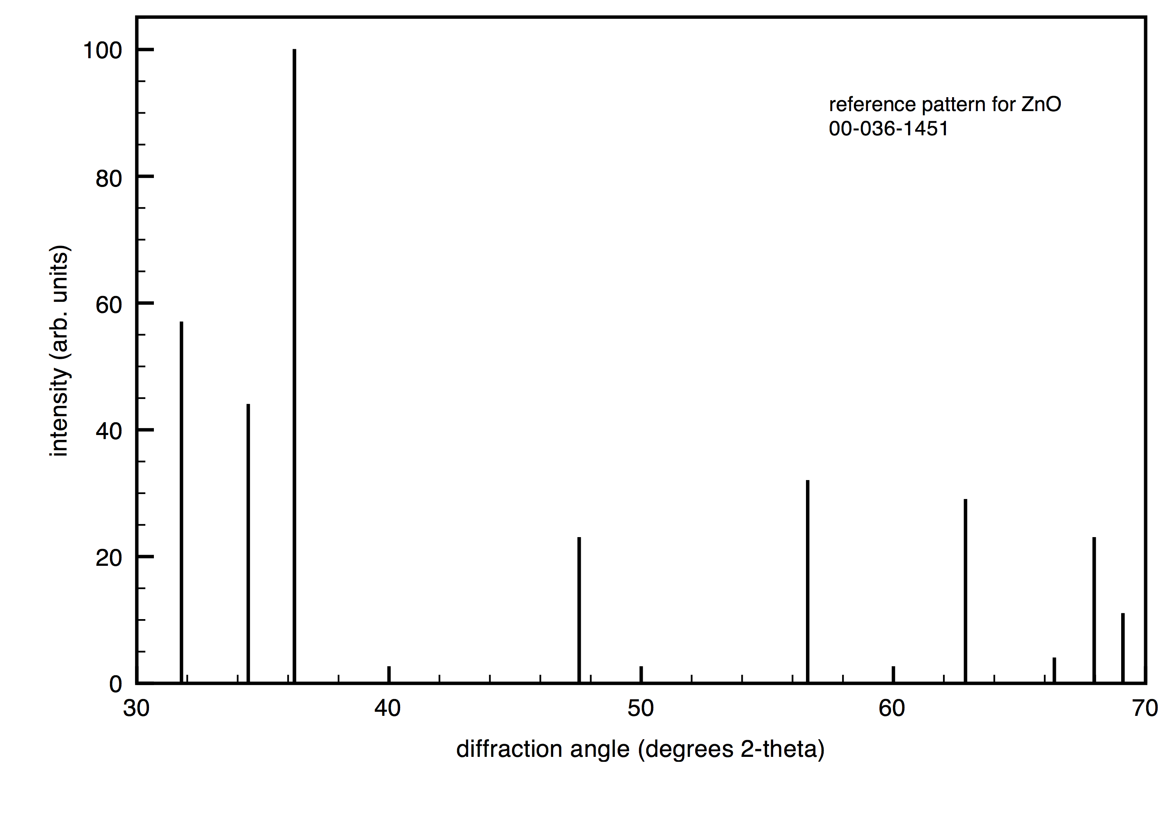
Peak positions for intense peaks (º 2θ):
31.820
34.331
36.496
47.569
57.168
63.204
67.861

PROCEDURE

Week 1: Synthesis

Weigh 0.15 g of LiOH⋅H₂O and transfer the solid to a 125 mL Erlenmeyer flask. Add 25 mL of absolute ethanol and a magnetic stir bar and stir for about 10 min to dissolve the solid. In the meantime, prepare two ice baths, making one of them in a plastic basin.

Weigh 0.55 g of Zn(OAc)₂⋅2H₂O and transfer it to a 125 mL Erlenmeyer flask. Add 25 mL of absolute ethanol and a magnetic stir bar. Place the flask on a hotplate and cover it with a watch glass. While stirring, heat the mixture until boiling to dissolve the solid. Remove the flask from the heat as soon as the solution boils and becomes clear.

Cool both solutions to 0ºC by putting each flask in an ice bath. Use the ice bath in the plastic basin for chilling the zinc acetate solution and place the entire bath on a cool stir-plate. Use of the plastic basin is important because an enameled steel basin will interfere with the function of the magnetic stirrer. Make sure that the solutions are thoroughly chilled before proceeding because a low reaction temperature is essential for producing nanometer-scale particles. This will take at least 20 min of equilibration in the ice baths.

Once both solutions are cold, use a Pasteur pipet to gradually add the lithium hydroxide solution to the zinc acetate solution, stirring with the magnetic stir bar. Keep the lithium hydroxide solution in the ice bath while you do this, withdrawing one pipetful at a time to add to the zinc acetate. Add the lithium hydroxide solution at a rate of several drops per second. This gradual combination of the reagents is another factor that promotes formation of the desired nanometer-scale particles.

You may notice that the mixture becomes cloudy during mixing, but it should become clear again once all of the lithium hydroxide is added. Remove the flask from the ice bath and allow it to come to room temperature. You may find it helpful to use a bath of slightly warm tap water to speed up the warming of the sol. This mixture is clear and colorless because ZnO nanoparticles are transparent to visible light; however, the nanoparticles absorb UV light, resulting in a yellow-green fluorescence. If you wish, ask the TA or instructor to help you view your sample under UV light.

Once the solution is at room temperature, add 60 mL of deionized water and stir to combine the solvents. Addition of water to the ZnO sol causes aggregation of the nanoparticles, as evidenced by the development of a cloudy appearance. The aggregated solid that emerges is very fine and will easily pass through filter paper or a fritted funnel. For this reason, it is more easily isolated by centrifugation.

Label three 13 x 100 mm test tubes with your and your partner’s initials. Using a pipet, fill each test tube about three-quarters full with the reaction mixture. Spin the tubes in a centrifuge for 2 to 4 min, being careful that the centrifuge is balanced. After spinning, the mixture in each tube should be separated into a white, gelatinous solid beneath a clear liquid. Pour off the liquid, and add more of the reaction mixture to each tube on top of the white solid. Spin the tubes again to collect more product, and pour off the clear liquid. Repeat this process with the three test tubes until you have isolated all of the product from your reaction mixture.

The solid that you have isolated in the test tubes consists of aggregated ZnO nanoparticles, precursor compounds and entrained solvent. In order to dry the product and complete conversion of the precursor to ZnO, the gel must be dried under vacuum and then heated in a drying oven.

Use rubber bands to secure your test tubes in a bundle. Ask a member of the laboratory staff to assist you in putting your samples into the vacuum drying apparatus, located in room N387. After the product dries overnight under vacuum, the instructor will transfer the tubes to a 120ºC drying oven, where they will heat for 3 hr. Your cooled, dried product will be ready for you to analyze by X-ray diffraction during the second week of the experiment.

Week 2: X-Ray Analysis

Pre-weigh a piece of weighing paper and crease it diagonally. Using a metal spatula, scrape as much dried product as possible from your test tubes onto the paper. Weigh the product and transfer it to a vial. Performing this transfer over a second piece of paper is a good idea since it provides a way to recover any material that is spilled.

The X-ray diffractometer is in room W010 in physics. You will find there an aluminum sample holder, a mortar and pestle, and glass microscope slides. When you arrive at the diffractometer, the instrument will be on, and the tube will be powered at 40 kV and 44 mA, the desired settings for your experiment. Your TA will guide you through the following steps for collecting your powder X-ray diffraction pattern:

Sample Preparation

1. Using the agate mortar and pestle, grind the sample to a uniform powder. Use a spatula to fill the well in the aluminum sample holder.

2. Use a glass microscope slide to compact the powder so that it is flush with the top of the sample holder.

Data Collection

- Check to make sure that the instrument shutter is closed. Safety interlocks are in place to prevent users from opening the instrument when the shutter is open, but it is a good practice to be aware of the shutter status. When the shutter is open, a large, red, C-shaped LED is lit on the lefthand side inside the instrument chamber and can be seen through the window. In addition, the shutter control icon in the XG window on the computer is red and yellow. This icon is gray when the shutter is closed.
- Unlock the diffractometer doors by pressing the “door lock” button on the front of the instrument. A beeping sound indicates that the doors are unlocked. Gently pull the doors apart. Slide your sample holder into place between the semicircular piece of metal at the center of the instrument and the spring-loaded clips just below it.
- Gently close the doors and press “door lock” once more. The beeping will stop to indicate that the doors are locked.
- Double-click on the red and yellow Standard Measurement icon on the PC desktop.
- A measurement condition has already been prepared for your experiment. The scan will go from 30º to and 70º 2θ and will take approximately 10 minutes. Choose a filename for your data by clicking on the Browse button on the line corresponding to the selected condition. In the box that appears, navigate to OS (C:), then XRD-DATA. Within this folder, select the folder that has been set up for Chem 213. Once in the desired folder, enter a file name consisting of your and your partner’s initials and click Open.
- Enter the desired sample name on the line corresponding to the selected condition. This can be the same as or different from your data file name.
- Click the yellow measurement icon to begin the scan. The instrument will take several seconds to get into position, and data collection will begin. The diffraction pattern will begin to appear in the Standard Measurement profile window.
- At the completion of the experiment, the Standard Measurement profile window can be closed by going to File and Quit or clicking on the red X in the upper right corner. A box will appear asking if you are sure you want to close the window. Click Yes to continue closing. Also close the Standard Measurement condition window by clicking in its upper right corner. A window will appear saying that the measurement conditions have changed. Click Yes to save the changes and continue closing.
- After the measurement has stopped and the shutter has closed, press the “door lock” button to unlock the instrument doors. Open the doors and remove your sample holder. Gently close the doors and press the button to relock.
- Remove your sample from the holder and wipe the holder with a damp Kimpwipe or towel.
Processing and Printing
1. Double-click on the PDXL icon at the right on the PC desktop.
2. In the box that appears, leave “administrator” as the user name, and don’t enter a password. Click OK.
3. Go to File… and Load Measurement Data. Navigate to your saved file and open. Your file will appear with a peak list, including peak widths, below.
4. Go to File… and Print… In the box that appears, check “profiles with header” and “peak list”. Click Print to generate your printed pattern.

Analysis of the X-Ray Diffraction Pattern

1. Using your printed peak list, compare the peak positions in your powder pattern to the positions in the reference pattern. In your notebook, prepare a table of reference positions, observed positions, and the difference between the two. Does your pattern confirm the synthesis of ZnO?

2. Using data for the peaks at 2q = 47.6º, 57.2º and 63.2º, apply the Debye-Scherrer equation to estimate the average size of particles (D) in your sample. Note that the tabulated angles on the peak list are given in units of 2θ, so these values must be divided by 2 before being used in the equation. The value for the FWHM does not need to be divided by 2, but it must be converted to radians. Perform the calculation for each of the three peaks and then average your results.

