The National Fire Protection Agency (NFPA) symbol:

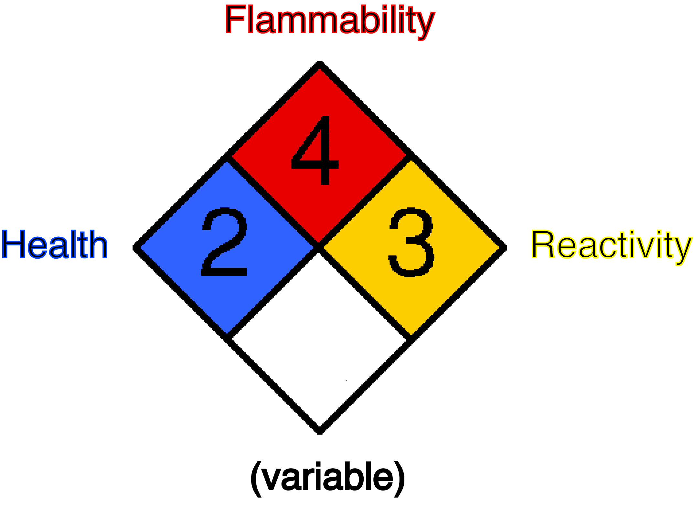

The bigger the number (from 0 to 4), the more dangerous the substance is.

