Determining Molecular Structure:
An Experimental Simulation of X-ray Diffraction

Implementation Notes: I typically do this during the first week of lab in my sophomore-level Introductory Inorganic Chemistry course. A few days before, the students spend one hour of conference (pre-lab) time working with Escher drawings to learn the language of unit cells, proper rotations, mirror planes, and glide planes. This is the first time that they have formally seen symmetry in the course.

Students typically work in groups of 3-4 for the experiment. The number of stations that I need depends on the enrollment in the lab section. In the lab, I set-up several lasers and clamps for Optical Transform slides at one end of the long benches, projecting the diffraction patterns on the sides of the hoods at the other end. We cover the hoods with large pieces of paper that the students can draw the diffraction patterns on and then take away to another room in the light to make their measurements and discuss observations. The lab must be fairly dark to see some of the fainter diffraction spots; I cover all the windows with black cloth and hope for a cloudy day.
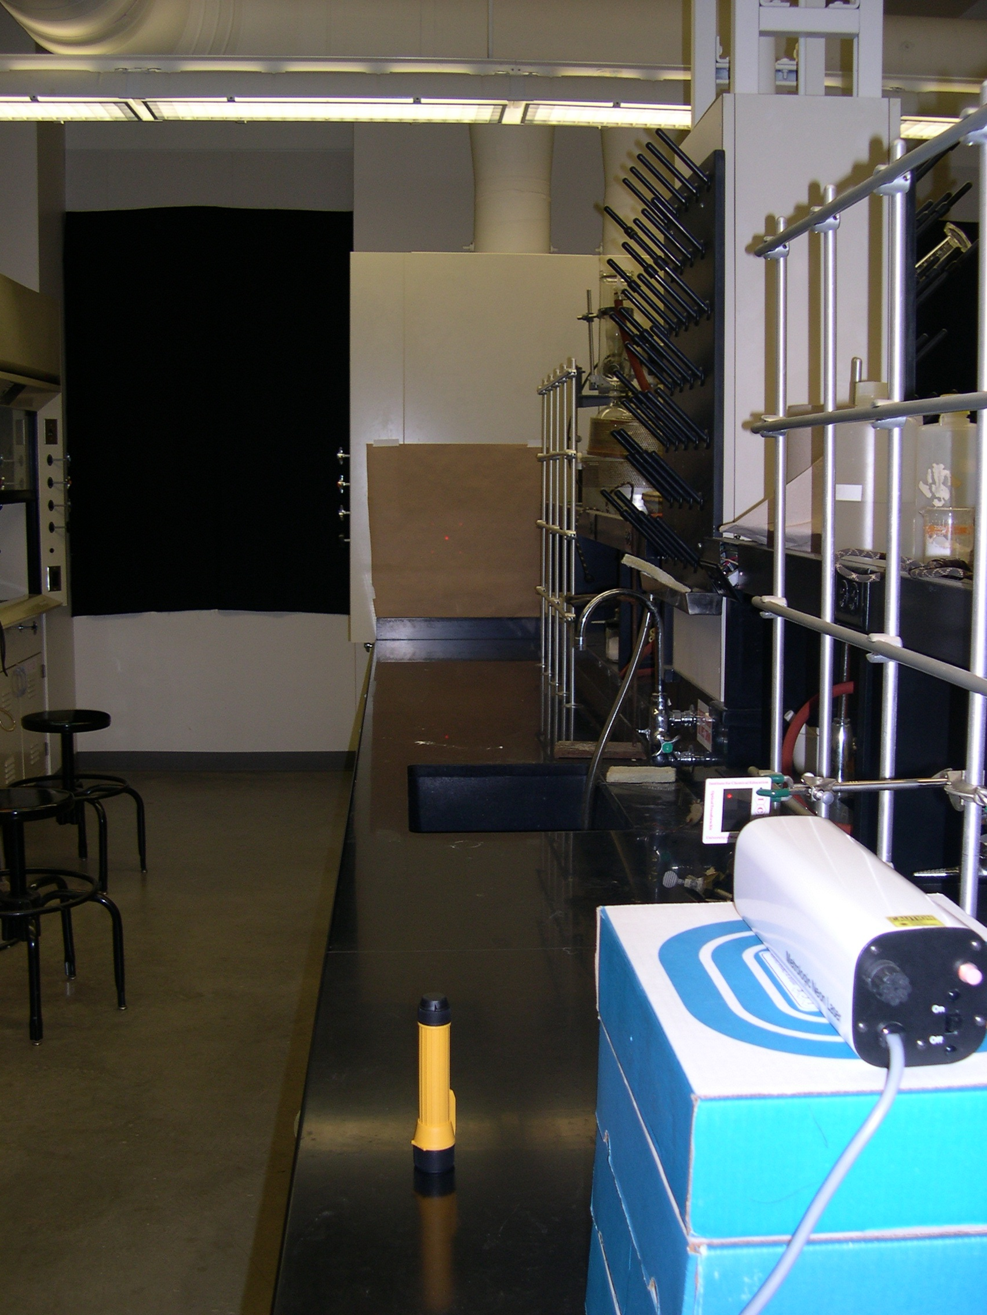
Diffraction pattern
OT Slide
Lab window
Laser
Here is a photo of the set-up I use. When the lights are off, the diffraction pattern can be seen and drawn on the brown paper taped up on the side of the hood.

I circulate constantly during this lab, listening in on the conversations of each group and making sure that they are seeing all that I want them to see. The diffraction effects of the glide plane are the hardest to see and often I “lead” them to the right conclusion.

Grading: This lab is all done in their lab notebooks, which I collect and grade, making comments on how to keep a good and effective lab notebook. In the end, it is a relatively minor component of their lab grade, about 12%.

