Discussion questions for Werner’s Nobel Prize Address (1913)

• What did Werner mean by an “acid residue”?

• What did he mean by “loose vs. firm” acid residues? Experimentally, how do you think Werner might have distinguished these?

• What different chemical information might be conveyed by these two ammonia chain structures? What is the significance of longer or shorter chains?
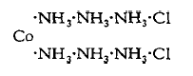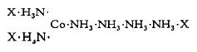
• Why did Werner think the chain theory could not be right? What experimental observations could not be explained by the chain theory?

• Explain how Werner’s model of complexes explains the experimental observations.

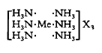
• What does Arrhenius have to do with the story?

• What is a strong, weak, nonelectrolyte? Examples of each?

• What did Werner mean by an “ionogenic group”? Example?

• What did Werner mean by an “intercalation compound”? Example? What might we call this today?

• What did Werner mean by “hydrate isomerism”?

• In the structure of complexes with CN=6, why did Werner argue that the 6 groups must be arranged symmetrically around the metal?

• What were the 3 choices of symmetrical structures for CN=6 and how did Werner prove his case for octahedral structures?

• Werner is often called the father of inorganic stereochemistry. How did he earn this name?

