Phosphine Donors

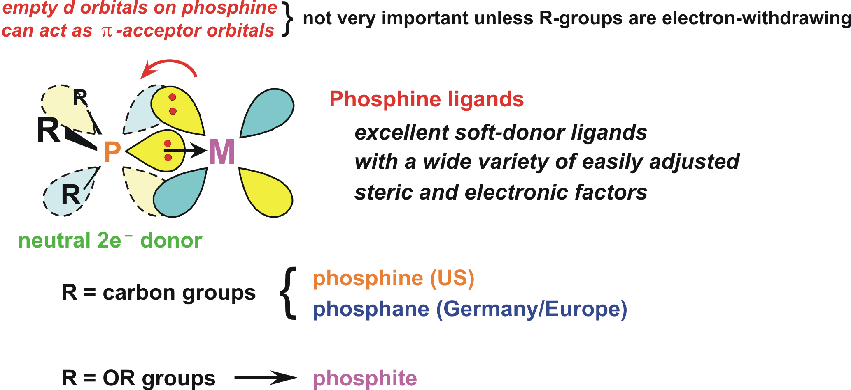

Because of the three R-groups on the phosphine ligand and the overall tetrahedral coordination geometry it is the most versatile of the neutral 2-electron donor ligands. Variation of the three R-groups can effect:
- large changes in the donor/acceptor properties of the phosphine (from excellent donor/poor π-acceptor to poor donor/excellent π-acceptor)
- large changes in the steric profile of the phosphine (from fairly small to enormous)
- generation of a large number of polydentate polyphosphines (bis-, tris-, tetra-, penta-, and hexaphosphine ligands are all known) that can adopt specific coordination geometries (cis-enforcing, facial tridentate, bridging, bridging and chelating, etc.)
Tolman’s Cone Angle and Electronic Parameter
In 1977 Chad Tolman (Dupont Chemicals) published a classic review article covering methods that he developed for ordering a wide variety of phosphine ligands in terms of their electron-donating ability and steric bulk (Chemical Reviews, 1977, vol 77, pages 313-348).
The electron-donating ability of a phosphine ligand was determined by reacting one equivalent of the phosphine (monodentate only) with Ni(CO)4 to make a Ni(CO)3(phosphine) complex. He then measured the carbonyl νCO IR stretching frequency (the very sharp a1 high energy mode) of the Ni(CO)3(phosphine) complex. The more electron density the phosphine ligand donated to the metal center, the more π-backbonding occurred to the carbonyl ligands, weakening the C≡O triple bond, thus lowering the νCO IR stretching frequency.
The size or steric bulk of a phosphine ligand was determined from simple 3-D space-filling models of the phosphine ligands. Tolman coined the name cone angle (θ) to indicate the approximate amount of “space” that the ligand consumed about the metal center.
Phosphine Donor Ability Ranked by
Tolman’s Electronic Parameter ν (most donating to least)
PR3 |  | mixed |  | P(OR)3 |  | PX3 |  | ν, cm−1
P(t-Bu)3 |  |  |  |  |  |  |  | 2056.1
PCy3 |  |  |  |  |  |  |  | 2056.4
P(o-OMe-C6H4)3 |  |  |  |  |  |  |  | 2058.3
P(i-Pr)3 |  |  |  |  |  |  |  | 2059.2
PBu3 |  |  |  |  |  |  |  | 2060.3
PEt3 |  |  |  |  |  |  |  | 2061.7
 |  | PEt2Ph |  |  |  |  |  | 2063.7
PMe3 |  |  |  |  |  |  |  | 2064.1
 |  | PMe2Ph |  |  |  |  |  | 2065.3
P(p-OMe-C6H4)3 |  | PPh2(o-OMe-C6H4) |  |  |  |  |  | 2066.1
PBz3 |  |  |  |  |  |  |  | 2066.4
P(o-Tol)3 |  |  |  |  |  |  |  | 2066.6
P(p-Tol)3 |  | PEtPh2 |  |  |  |  |  | 2066.7
 |  | PMePh2 |  |  |  |  |  | 2067.0
P(m-Tol)3 |  |  |  |  |  |  |  | 2067.2
 |  | PPh2(NMe2) |  |  |  |  |  | 2067.3
 | PPh2(2,4,6-Me-C6H2) |  |  |  |  |  |  | 2067.4
 |  | PPhBz2 |  |  |  |  |  | 2067.6
 |  | PPh2(p-OMe-C6H4) |  |  |  |  |  | 2068.2
 |  | PPh2Bz |  |  |  |  |  | 2068.4
PPh3 |  |  |  |  |  |  |  | 2068.9
 |  | PPh2(CH=CH2) |  |  |  |  |  | 2069.3
P(CH=CH2)3 |  | PPh2(p-F-C6H4) |  |  |  |  |  | 2069.5
 |  | PPh(p-F-C6H4)2 |  |  |  |  |  | 2070.0
P(p-F-C6H4)3 |  |  |  |  |  |  |  | 2071.3
 |  | PPh2(OEt) |  |  |  |  |  | 2071.6
 |  | PPh2(OMe) |  |  |  |  |  | 2072.0
 |  | PPh(O-i-Pr)2 |  |  |  |  |  | 2072.2
P(p-Cl-C6H4)3 |  |  |  |  |  |  |  | 2072.8
 |  | PPh2H |  |  |  |  |  | 2073.3
 |  | PPh(OBu)2 |  |  |  |  |  | 2073.4
P(m-F-C6H4)3 |  |  |  |  |  |  |  | 2074.1
 |  | PPh(OEt)2 |  |  |  |  |  | 2074.2
 |  | PPh2(OPh) |  |  |  |  |  | 2074.6
 |  | PPh2(C6F5) |  |  |  |  |  | 2074.8
 |  |  |  | P(O-i-Pr)3 |  |  |  | 2075.9
 |  |  |  | P(OEt)3 |  |  |  | 2076.3
 |  | PPhH2 |  |  |  |  |  | 2077.0
P(CH2CH2CN)3 |  |  |  |  |  |  |  | 2077.9
 |  |  |  | P(OCH2CH2OMe)3 |  |  |  | 2079.3
 |  |  |  | P(OMe)3 |  |  |  | 2079.5
 |  | PPh(OPh)2 |  |  |  |  |  | 2079.8
 |  |  |  | PPh2Cl |  |  |  | 2080.7
 |  |  |  | PMe2CF3 |  |  |  | 2080.9
 |  |  | P(O-2,4-Me-C6H3)3 |  |  |  | PH3 | 2083.2
 |  |  |  | P(OCH2CH2Cl)3 |  |  |  | 2084.0
 |  |  |  | P(O-Tol)3 |  |  |  | 2084.1
 |  |  |  | P(OPh)3 |  |  |  | 2085.3
 |  |  |  | P(OCH2)3CR |  |  |  | 2086.8
 |  |  |  | P(OCH2CH2CN)3 |  |  |  | 2087.6
 |  | P(C6F5)3 |  |  |  |  |  | 2090.9
 |  |  |  |  |  | PCl3 |  | 2097.0
 |  |  |  |  |  | PF3 |  | 2110.8
Problem: Order the following phosphines from strongest to weakest σ donor:
P(OEt)3 | PPh3 | PPr3 | PCl3 | PPh(OMe)2
Phosphine Steric Bulk Ranked by
Tolman’s Cone Angle θ (smallest to largest)
PR3 |  | mixed | P(OR)3 | PX3 | θ (°)
 |  |  |  | PH3 | 87
 |  | PPhH2 | P(OCH2)3CR |  | 101
 |  |  |  | PF3 | 104
 | Me2PCH2CH2PMe2 |  | P(OMe)3 |  | 107
 |  |  | P(OEt)3 |  | 109
 |  | P(CH2O)3CR |  |  | 114
 |  | Et2PCH2CH2PEt2 |  |  | 115
 |  | P(OMe)2Ph or Et |  |  | 115
 |  | PPh(OEt)2 |  |  | 116
PMe3 |  |  |  |  | 118
 |  | Ph2PCH2PPh2 |  |  | 121
 |  | PMe2Ph |  |  | 122
 |  |  | PMe2CF3 | PCl3 | 124
 |  | Ph2PCH2CH2PPh2 |  |  | 125
 |  | PPh2H | P(OPh)3 |  | 128
 |  |  | P(O-i-Pr)3 |  | 130
 |  |  |  | PBr3 | 131
PEt3, PPr3, PBu3 |  | PPh2(OMe) |  |  | 132
 |  | PPh2(OEt) |  |  | 133
 |  | PEt2Ph, PMePh2 |  |  | 136
P(CF3)3 |  |  |  |  | 137
 |  | PEtPh2 |  |  | 140
 |  | Cy2PCH2CH2PCy2 |  |  | 142
PPh3 |  |  |  |  | 145
 |  | PPh2(i-Pr) |  |  | 150
 |  | PPh2(t-Bu) |  |  | 157
 |  | PPh2(C6F5) |  |  | 158
P(i-Pr)3 |  |  |  |  | 160
PBz3 |  |  |  |  | 165
PCy3 |  | PPh(t-Bu)2 |  |  | 170
 |  |  | P(O-t-Bu)3 |  | 175
P(t-Bu)3 |  |  |  |  | 182
 |  | P(C6F5)3 |  |  | 184
P(o-Tol)3 |  |  |  |  | 194
P(mesityl)3 |  |  |  |  | 212

Problem: Order the following phosphines from largest to smallest:
P(OEt)3 | PPh3 | PPr3 | PCl3 | PPhCy2

Problem: Order the following phosphines from best π-acceptor to worst π-acceptor:
P(OEt)3 | PPh3 | PPr3 | PCl3 | PPhCy2

Commonly Used Monodentate Phosphines:

PPh3 (145°, medium donor), triphenylphosphine, tpp “The KING”
- air-stable, white crystalline material, no odor to speak of

Increasing σ-Donor Ability:
PMePh2 (136°), PMe2Ph (122°), PMe3 (118°), PEt3 (132°)
P(Cy)3 (170°) tricyclohexylphosphine, P(t-Bu)3 (182°)
- the alkyl phosphines are strong σ-donors; usually colorless liquids, somewhat to very air-sensitive, horrible smelling (unless very high MW and non-volatile)

Poor σ-Donors, Good π-Acceptors:
Phosphites: P(OMe)3 (107°), P(OEt)3 (110°), P(OPh)3 (128°)
- phosphites are relatively poor σ-donors, but can be fairly good π-acceptor ligands (about half as good as CO); low MW ones are usually colorless liquids, higher MW compounds are white solids; usually air-stable but moisture sensitive; sometimes sweet smelling

PF3 (104°) } v. poor donor; strong π-acceptor, almost as good as CO

Commonly Used Polydentate Phosphines:

Some Other Polydentate Phosphines:

Polyphosphine review: Cotton & Hong, Progress in Inorg. Chem., 1992, 40, 179-289.
Some Structural Issues
Phosphines have only been characterized as simple 2 e− donating, terminal-only ligands. No true μx-bridging monophosphines are known (although bridging phosphides, PR2−, are very common).
Phosphines generally tend to orient trans to one another in order to minimize steric interactions (especially true for bulky PR3). Chelating bisphosphine ligands are used to enforce cisoidal coordination geometries when needed.
Some typical first row M-PR3 average bond distances:
Ti-P | 2.6 Å
V-P | 2.5 Å
Cr-P | 2.4 Å
Ni-P | 2.1 Å
M-P distances decrease due to the contraction of the metal atom radius as one proceeds to the right and the atoms become more electronegative. Distances also decrease due to stronger M-P bonding as one moves to the right across the transition metal series (later transition metals are “softer” and prefer bonding to phosphines).
M-P bonds are usually the strongest for alkylated phosphine ligands bonding to a neutral middle to later transition metal center that is electron-deficient. High oxidation state early transition metals are too “hard” to have very effective bonding to most phosphines, although more and more early transition metal phosphine complexes are being characterized and found to be reasonably stable.
Metal centers that are too electron-rich will generally not want to have a strong electron-donating alkylated phosphine coordinated, this leads to weaker M-P bonding and more likely phosphine dissociation. One example is Rh2(μ-CO)(CO)4(P4), shown below, that rearranges to form the asymmetric μ,η3,η1-P4 coordinated dimer, shown to the right, when one CO ligand is lost:
This is a fully reversible CO and temperature dependent equilibrium. The asymmetric dimer, which has been structurally characterized, can be considered to be zwitterionic: one cationic Rh(+1) center that has 3 phosphines coordinated and an anionic Rh(−1) pseudo-tetrahedral center that has 3 π-accepting CO ligands. One of these CO’s is acting as a semi-bridging ligand π-donating some electron density to the other formally cationic square-planar rhodium.
Bond Length vs. Bond Strength
Aroney & coworkers (Inorg. Chem., 1995, 34, 330-336) claimed that the shorter Cr-PCl3 bond in Cr(CO)5(PCl3) vs. Cr(CO)5(PMe3) was a result of strong π-backbonding. They did NOT make any statements about bond strengths, but implied that the Cr-PCl3 bond is shorter and, therefore, stronger than the Cr-PMe3 bond.
Let’s compare the P lone pair orbital for free PCl3 and PMe3 ligand, which is the highest occupied molecular orbital (HOMO):
PCl3
PMe3
HOMO energy = −8.36 eV −6.23 eV
Note the higher energy (better σ donor) and greater orbital extent of the P lone pair on PMe3 (right plot). This means that the PMe3 ligand does not have to get as close to the metal center as PCl3 in order to get good bonding overlap.
Below are shown single-point (no geometry optimization) DFT calculations on Cr(CO)5(PCl3) and Cr(CO)5(PMe3) based on their crystal structures, followed by calculations with the phosphine ligands dissociated (4.0 Å separation) to see the relative change in energies.
Note the clear-cut π-backbonding between the PCl3 and the Cr center, while there is just a trace of π-backbonding in the Cr-PMe3 bond. Note that the Cr-CO ligand trans to the PCl3 has a bit more orbital extent indicating a little more π-backbonding ability.
The difference in total energies represents the difference in PMe3 vs. PCl3 bond energies:
ΔΔE Bond dissociation =
(ΔE(bonded-unbonded)PMe3) - (ΔE(bonded-unbonded)PCl3)
ΔΔE Bond dissociation = 6.8 Kcals (PMe3 system having stronger bonding)
Further Test: Examine PCl3 vs. PMe3 bonding to a d0 metal center: TiCl4(PCl3) and TiCl4(PMe3).
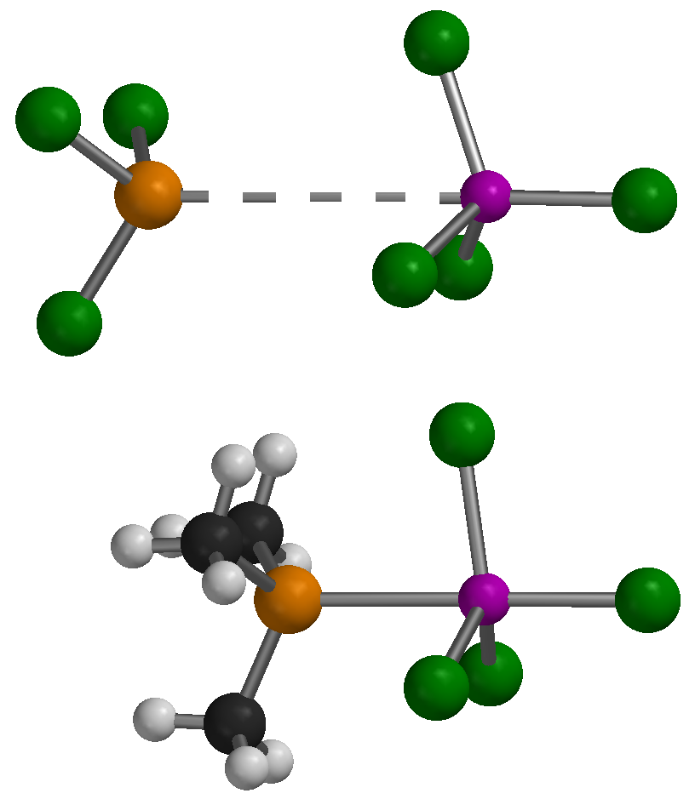In this d0 system the lack of any π-backbonding possibilities and good Ti-Cl bonding favored complete dissociation of the poor σ donating PCl3 ligand. The far better PMe3 σ-donor, on the other hand, bonds nicely to the Ti(+4) d0 center.
2.69 Å
2.24 Å
2.18 Å
4.63 Å
Bond Length/Strength conclusions: For most systems a shorter bond usually indicates a stronger bond when comparing similar atoms and bonds.
For metal-ligand complexes there can be exceptions to this when the ligands in question have fairly different donor/acceptor properties. In Cr(CO)5(PCl3) the shorter bond distance relative to Cr(CO)5(PMe3) arises due to the combination of a contracted lower energy P orbitals and moderate to significant π-backbonding. The DFT calculations indicate that the PMe3 complex has stronger M-P bonding despite the significantly longer Cr-P distance (2.37Å vs. 2.24Å). The greater PMe3 lone pair orbital extent and higher energy (better donor ability) produces a strong M-P σ-bond with a longer bond distance relative to the PCl3.
In order to get effective π-backbonding in the Cr-PCl3 complex, the bond distance has to be shorter to get optimum orbital overlap. In the Ti(+4) d0 system the PCl3 ligand did not form a Ti-P bond, even though TiCl4 only has an 8e- count, due to the lack of π-backbonding and weaker σ-bonding ability relative to PMe3.

Problem: For each of the following pairs of metal complexes, which should have the highest average carbonyl IR stretching frequency.

a) CpFeBr(CO)2 -or- CpRuCl(CO)(PMe3)

b) MnCl(CO)5 -or- Cr(CO)6

c) (η3-allyl)Co(PPh3)(CO)2 -or- (η3-allyl)Co(PMe3)(CO)2

d) [Rh(CO)2(P(OPh)3)2]+ -or- Rh(CH3)3(CO)(dmpe)

e) Mo(CO)4(PMe3)2 -or- W(CO)4{P(OMe)3}2

f) CpRe(CO)2{P(OMe)3} -or- Hf(O)Cl2(CO)(PEt3)2

31P NMR Spectroscopy
The 31P (P-31) nucleus has a nuclear spin of ½ and is 100% abundant! This makes it functionally equivalent to the 1H nucleus: therefore, 31P NMR is an extremely valuable tool in studying phosphines in general, and M-PR3 complexes in particular. This is another reason why phosphines are such valuable ligands.
The typical chemical shift region for 1H NMR spans about 20 ppm. The 31P NMR chemical shift region, however, is much larger and can span almost 1000 ppm (including phosphide ligands)! Chemical shifts for some phosphines are listed below:
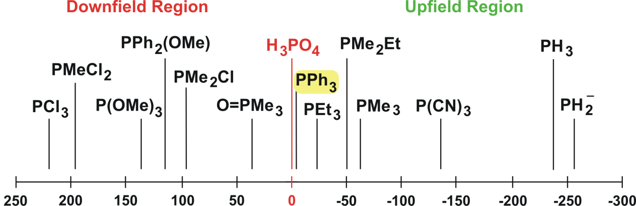

Ligand | Chemical Shift (ppm) | Ligand | Chemical Shift (ppm)
PCl3 | 220 | H3PO4 | 0 (reference)
PMeCl2 | 191 | P(CF3)3 | -2
PCy(OBu)2 | 184 | PPh3 | -6
P(OMe)3 | 140 | PEt3 | -20
P(OPh)3 | 126 | NaPPh2 | -24
PEt2Cl | 119 | PMePh2 | -28
PPh2(OMe) | 115 | PPr3 | -33
PF3 | 97 | PMe2Et | -50
PMe2Cl | 96 | PMe3 | -62
PMe2(O-t-Bu) | 91 | P(CN)3 | -135
O=P(CH2OH)3 | 45 | PH3 | -238
O=PMe3 | 36 | KPH2 | -255

It is important to note that the positive and negative convention for chemical shifts for 31P NMR compounds changed in the early 1970’s. In these older references, free PMe3 would be listed with a +62 ppm chemical shift.
Chelate Ring Effects:
The presence of chelate rings can have a significant effect on the 31P NMR chemical shift position of M-P complexes (Cf., Garrou, Chem. Rev., 1981, 81, 229):
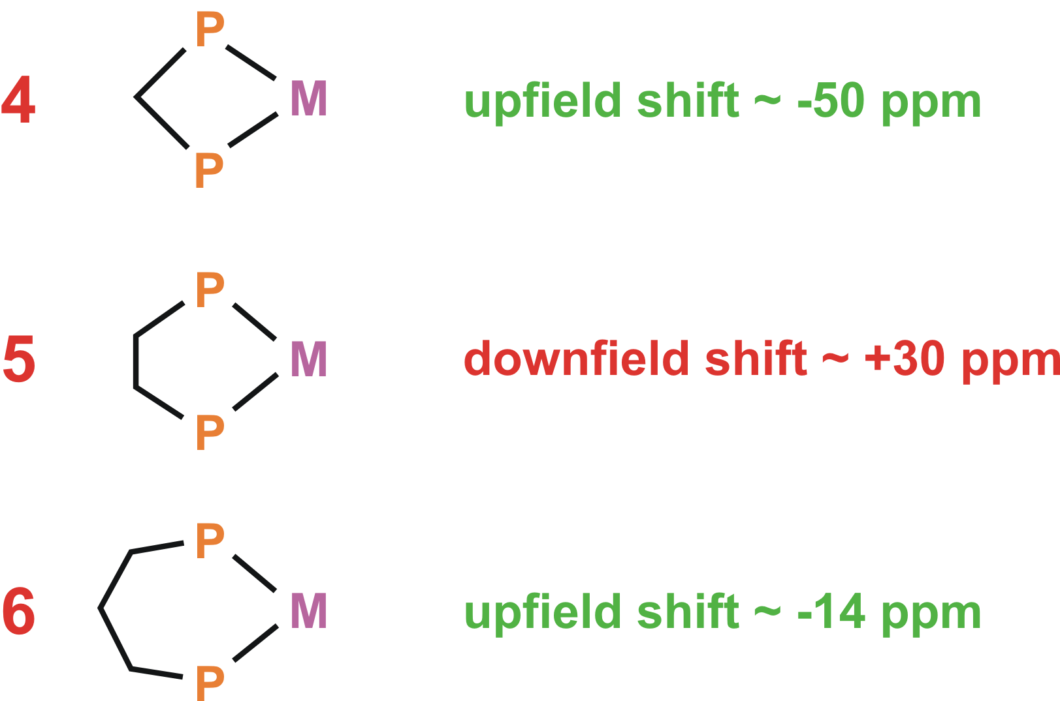
Similarly, the metal center can also have a considerable shifting effect. Consider the following dppm chelates with 4-member rings:
W(CO)4(η2-dppm) | −23.7 ppm
Mo(CO)4(η2-dppm) | 0 ppm
Cr(CO)4(η2-dppm) | 23.5 ppm

31P NMR, as with 1H and 13C methods, can be exceptionally useful in characterizing metal-phosphine complexes and structures:

Problem: Which of the following complexes will have the highest νCO stretching frequency in the IR? Why?

A) [Mn(CO)3{P(OPh)3}3]+

B) W(CO)3(PEt3)3

C) [(PF3)Ag(CO)]+

Problem: Which of the following complexes will have the lowest νCO stretching frequency in the IR? Why?

A) Ni(CO)(PMe3)3

B) Fe(CO)4(PPh3)

C) [Re(CO)2{P(OMe)3}4]+

