Alkenes & Alkynes

Alkenes act as neutral 2e- donors (per C=C double bond). Due to the presence of empty π* antibonding orbitals, there is the possibility of some π-backbonding:
Alkenes are typically relatively weakly coordinating ligands. They are also extremely important substrates for catalytic reactions. The strongest alkene-metal bonds occur with third row metals (as with almost all ligands) and when one can get more π-backbonding to occur. The amount of π-backbonding depends strongly on how electron-rich the metal center is and whether or not there are electron-withdrawing groups on the alkene to make it a better acceptor ligand.
In extreme cases, as shown above to the right, if the metal is electron-rich enough and if there are electron-withdrawing groups on the alkene (like the CN’s), one can actually get a formal oxidation of the metal via the transfer of 2e- to the alkene to form a dianionic metallocyclopropane ligand that is now coordinated via two anionic alkyl σ-bonds (thus the assignment of Pt(+2)).
Another interesting comparison is shown to the right where we have two different alkenes coordinating to the same metal center. The electron-withdrawing fluorine groups on the F2C=CF2 alkene makes it a better π-acceptor ligand. This weakens the C=C bond, but strengthens the alkene-metal bond.

Another series of structures is shown below for butadiene, Fe(η4-C4H6)(CO)3, and Cp2Zr(η4-C4H6):
In this series one can see that the combination of π-backdonation from the Fe and σ-donation from the alkenes to the Fe weaken and lengthen the C=C bond. In the Zr complex, however, we see an interesting reversal where the single bond across the back of the butadiene shortens quite a bit. What is happening here is that the Zr is in a very low oxidation state (+2, but it really wants to be +4) and is, therefore, extremely electron-rich. So electron-rich that it transfers two electrons to the butadiene via the π-backdonation and generates a metallocyclopentene resonance structure, shown schematically to the right.

More Electronic Effects
Electronic effects with alkenes can often be somewhat easily monitored using infrared (IR) spectroscopy, much as with CO ligands. The more π-backbonding, the weaker the C=C double bond and the lower the C=C stretching frequency in the IR. The table below shows a series of alkene compounds with differing amounts of σ-donation and π-backbonding. Note that both weaken the C=C bond and lower the stretching frequency, although the π-backbonding has by far the larger effect.
Ethylene Complex | νC=C  (cm−1)
Free Ethylene | 1623
[Ag(H2C=CH2)2]+ | 1584
Fe(CO)4(H2C=CH2) | 1551
[Re(CO)4(H2C=CH2)2]+ | 1539
[CpFe(CO)2(H2C=CH2)]+ | 1527
Pd2Cl4(H2C=CH2)2 | 1525
[PtCl3(H2C=CH2)]− | 1516
CpMn(CO)2(H2C=CH2) | 1508
Pt2Cl4(H2C=CH2)2 | 1506
CpRh(H2C=CH2)2 | 1493

The Ag+ complex is believed to have no π-backbonding, so the drop in the C=C stretching frequency is completely due to σ-donation from the alkene to the Ag+.
Carefully examine the compounds in the table and see if the changes in the C=C stretching frequencies make sense relative to your perceptions of how electron-rich the metal center is (allowing you to judge the amount of π-backdonation) and how strongly the alkene might be σ-bonding to the metal (a relatively minor contribution compared to the effect of π-backdonation).
The thermodynamic stability of metal-alkene complexes is strongly affected by the nature of the alkene (and metal):
1) Electron-withdrawing groups on the alkene generally increase the strength of the metal-alkene bonding, while electron-donating groups generally decrease the stability.
2) In cases where cis-trans isomerism is possible, the more stable complex is almost always formed by the cis-alkene (steric factors).
3) Metal complexes of ring-strained cycloalkenes (e.g., cyclopropene) display higher than expected stability. The ring strain raised the energy of the cycloalkene ring system making it a better donor to the metal center (better orbital energy matching). See the next section on cyclobutadiene for a particularly remarkable example.
4) Chelating dienes show the expected stabilization from the chelate effect. The most common examples are norbornadiene and cyclooctadiene shown below. Note that these can still be easily substituted off the metal by stronger coordinating ligands such as phosphines.
5) Third-row metals form the strongest bonds and most stable complexes (as with most ligands).

Problem: To which of the following (each with a single open coordination site) will trifluoroethylene bond to the most strongly? Why?
Cyclobutadiene
Cyclic conjugated π-systems are aromatic if the number of π-electrons equals 4n + 2 (where n = an integer). Cyclobutadiene is an anti-aromatic since it has 4 π-electrons. The anti-aromaticity combined with the ring strain makes this simple molecule too unstable to exist as a free organic compound.
A triumph of the early days of organometallic chemistry was the successful synthesis of (η4-C4H4)2Ni2(μ-Cl)2Cl2, a stable metal-coordinated butadiene molecule, by Criegee in 1959. This was actually predicted theoretically by Longuet-Higgins and Orgel in 1956 using an early form of molecular orbital theory.
An even simpler route was discovered shortly after this involving the cyclodimerization of diphenyl acetylene by Fe(CO)5:
The high stability of a cyclobutadiene coordinated to a metal arises from the mixing of the 4 π electrons on the cyclobutadiene with one of the metal d orbitals that has 2 e- and the right symmetry to mix in and form a 6 π electron aromatic system! This is shown on the MO diagram on the next page. Note that the high energy (instability) of the non-bonding cyclobutadiene highest occupied molecular orbital (HOMO) allows it to interact extremely well with the metal orbitals that are at approximately the same energy.
Alkynes
Alkynes are essentially like alkenes, only with another perpendicular pair of π-electrons. Thus they can act as neutral 2 or 4 e- donors, depending on the needs of the metal center. They are much better bridging ligands because of this second set of π-electrons.
Note how the bridging alkyne is drawn. This indicates a perpendicular bridging mode and that both carbons are interacting equally with both metals (the alkyne is donating 2e- to each metal). It dos NOT indicate that each carbon has 6 bonds to it !!
Alkynes are better donors compared to alkenes and typically coordinate far more readily to a metal for steric (more open, less hindered) and electronic (better donor, 2 or 4e- bonding) reasons. They are also quite a bit more reactive for doing C-C coupling and other reactions.
When alkynes bridge, they almost always do so perpendicular to the M-M axis, the parallel bridging mode is known, but quite rare:
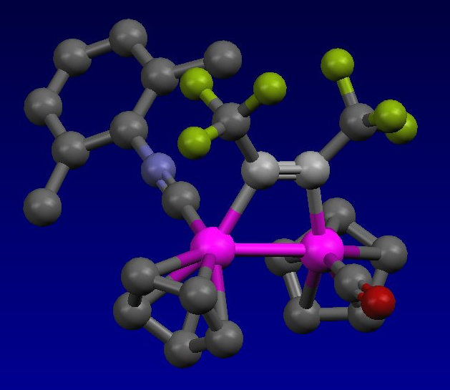 | 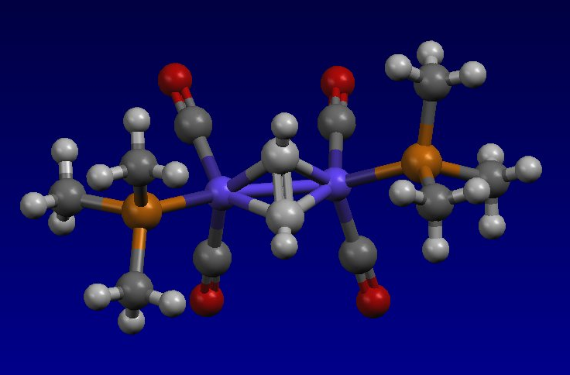
Cp2Rh2[μ-(CF3C≡CCF3)](CO)(CNR) | Co2[μ-(HC≡CH)](CO)4(PMe3)2

Problem: The Cp2Rh2[μ-(CF3C≡CCF3)](CO)(CNR) complex shown above has a Rh-Rh bond distance of 2.67 Å, strongly indicating a covalent bond between the rhodium atoms. How would you electron count this complex to accommodate a Rh-Rh covalent bond?

Problem: Which of the following ligands will coordinate the most strongly to a generic metal center (not too electron-rich or deficient, with enough open coordination sites)?

