**Arenes**

Created by George G. Stanley, Department of Chemistry, Louisiana State University (gstanley@lsu.edu) and posted on VIPEr on August 14, 2017. Copyright Geroge G. Stanley, 2017. This work is licensed under the Creative Commons Attribution-NonCommercial-ShareAlike CC BY-NC-SA. To view a copy of this license visit {http://creativecommons.org/licenses/by-nc-sa/4.0/}.

Arenes (benzene being the simplest member of this family) typically coordinate in an 6 fashion and as such are **neutral 6 e- donors**, although they can adopt lower coordination modes (4 and 2).



Synthesis: The first metal-benzene complex was prepared in 1955 by Fischer and Hafner:

**1. Na2S2O4**

**1. AlCl3**

**3CrCl3** + **2Al** + **6C6H6  3[Cr(6-C6H6)2]**+ ** Cr(6-C6H6)2**

**2. KOH**

**2. H2O**

Limitations: Low yield, messy, difficult to isolate organometallic product. Also the arene must be inert towards the very reactive AlCl3. Alkylated arenes are isomerized by AlCl3. Arenes with substituents that have lone pairs available (e.g., haloarenes, anilines, phenols, etc.) are also unsuitable since they can bind to the AlCl3 and inhibit the reaction.

Metal-atom vapor synthesis was first used by Timms in 1969 to prepare Cr(C6H6)2. This involved the evaporation of elemental metals under high vacuum by heating them to very high temperatures (either resistively or by electron-beam impact). The evaporated metal atoms were condensed into a layer of frozen ligand and solvent (sometimes the same) coating the inside of a glass reaction flask at liquid nitrogen temperatures. Warming the flask up to the melting point of the solvent allowed the atomic metal and ligands to directly react to make the metal-ligand complex. Malcom Green, Ken Kabunde, and Philip Skell were all researchers actively involved in this area in the 70’s.

Limitation: Metal atom vapor reactor is very expensive and difficult to maintain.

**Some Properties of Metal-bis(arene) Complexes**

|  |  |  |  |
| --- | --- | --- | --- |
| **Complex** | **Color** | **mp/ºC** | **Miscellaneous** |
| Ti(C6H6)2 | red | ‑ | air‑sensitive, autocatalytic decomposition in aromatic solvents |
| V(C6H6)2 | red | 227 | very air‑sensitive, paramagnetic, reducible to [V(C6H6)2] |
| V(C6H5F)2 | red | ‑ | air‑sensitive |
| Nb(C6H6)2 | purple | - | very air‑sensitive, paramagnetic, decomposes at ca. 90'C |
| Cr(C6H6)2 | brown | 284 | air‑sensitive, the cation [Cr(C6H6)2]+ is air‑stable. *Eº* = 0.69 V in DME against SCE |
| Mo(C6H6)2 | green | 115 | very air‑sensitive |
| W(C6H6)2 | yellow‑green | 160 | less air‑sensitive than Mo(C6H6) |
| [Mn(C6Me6)2]+ | pale pink | ‑ | diamagnetic |
| [Fe(C6Me6)2]2+ | orange | - | reducible to [Fe(C6Me6)2]+, violet, and to Fe(C6Me6)2, black, paramagnetic, extremely air‑sensitive |
| [Ru(C6Me6)2]2+ | colorless | - | air‑stable, diamagnetic; reducible to Ru(C6Me6)2, orange, diamagnetic, very air-sensitive |
| [Co(C6Me6)2]+ | yellow | - | Paramagnetic; reducible to Co(C6Me6)2, very air‑sensitive |

Adapted from Elschenbroich & Salzer, “Organometallics”, VCH, 1989

-Backbonding

An interesting aspect of metal-arene complexes is that -backdonation plays a relatively important role in the bonding and chemistry. Arenes often do not coordinate very strongly to metals, but as one can tell from the list above, they do tend to favor metals in low oxidation states and often generate surprisingly stable complexes. Cr(C6H6)2, for example, is kinetically inert to most substitution reactions, no doubt due to its 18 e- configuration, but also due to the mix of -bonding and backbonding. But remember that CO and NO+ are far, far stronger -backbonding ligands.

Structural Features

The parallel sandwich structures have the following features:

|  |  |  |
| --- | --- | --- |
| **Distances (Å)** | | |
| **M** | **M-C** | **Ar…Ar** | **C-C** |
| **Benzene** | **--** | **--** | **1.39** |
| **Ti** | **2.22** | **3.48** | **1.38** |
| **Nb** | **2.33** | **3.72** | **1.41** |
| **Cr** | **2.14** | **3.21** | **1.42** |
| **[Cr]+** | **2.10** | **3.20** | **1.36** |
| **Me6-[Fe]2+** | **2.14** | **3.26** | **1.38** |
| **Me6-[Ru]2+** | **2.25** | **3.50** | **1.40** |
| **[Ru]2+** | **2.22** | **3.42** | **1.42** |

Note that the C-C bond distances in the arene are not a particularly reliable gage of the amount of -backbonding. The decrease in ring separation in going from [Ru(C6H6)2]2+ to the hexamethylbenzene complex, [Ru(C6Me6)2]2+ is caused by the increased electron density on the hexamethylbenzene that makes it more electron-rich and a better donor group (although that doesn’t always lead to bond shortening). The Cr-C shortening in the cationic complex probably results from the contraction of the Cr d orbitals due to the localized positive charge.

**Problem: The crystal structure of** [Cr(C6H6)2]+ **on the right clearly shows that the hydrogen atoms on the benzene distinctly lean in towards the metal center. Explain why.**

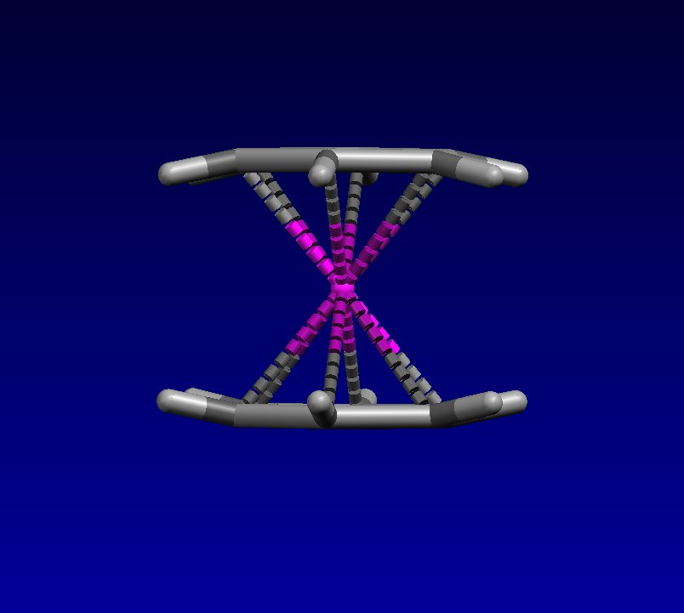

A dramatic example of the “power” of the 18e- electronic configuration is seen for the [Ru(C6Me6)2]2+ complex. This can be reduced to neutral Ru(C6Me6)2, but electron-counting with two 6-C6Me6 ligands gives you a 20e- complex. Violations of the 20e- rule are most common for first row metals where the metal-ligand bonding interactions are weaker leading to less destabilization when one occupies an M-L antibonding orbital when going past 18e-. But for 2nd and 3rd row metals that have increasingly stronger metal-ligand bonding, going past 18e- costs considerably more from a stability viewpoint.



Indeed, the structure of Ru(C6Me6)2 (shown to the right) reveals that one of the arene rings is strongly folded to give a 4e- 4-coordination geometry. Thus, the correct formulation of this compound is Ru(4-C6Me6)(6-C6Me6), which does give an 18e- count.

**Problem: In which of the following complexes should the 6-benzene ligand coordinate the strongest?**

