Name:_____________________

Heteronuclear Diatomic MOs

Learning Goals:

1. Construct a heteronuclear, diatomic MO diagram based on energy and symmetry considerations.

2. Analyze a heteronuclear, diatomic MO diagram to describe bonding and molecular structure.

1. Review: Homonuclear diatomic MOs
   1. Draw the MO diagram for F2. (remember to use the z axis as the bonding axis)
   2. What is the bond order?
   3. Why did we not need to include the F 1s orbitals in the diagram?
   4. The 2s on the first F and 2pz on the second F could interact based on symmetry but they do not interact. Why don’t they interact?
2. Let’s consider the molecule HF
   1. The energy of the orbitals are as follows:

|  |  |
| --- | --- |
| Orbital | Energy |
| H 1s | –13.6 eV |
| F 2s | –40.2 eV |
| F 2p | –18.7 eV |

Do you think the H 1s orbital will interact with the F 2s orbital or the F 2pz orbital? Why?

* 1. Will the F 2px orbital interact with the H 1s? Why or why not?
  2. Will the F 2 py orbital interact with the H 1s? Why or why not?

1. Drawing the MO diagram.
   1. In the F2 diagram that you drew, the graph was symmetrical because orbitals on the first F were the exact same energy as the orbitals on the second F. Do you think the MO diagram for HF will be symmetrical or will it be lopsided? Why?
   2. Draw the MO diagram for HF following the directions below. (remember to use the z axis as the bonding axis)
      1. Draw the AO diagram for H on the left. Draw the AO diagram for F on the right. Remember the relative energy levels of the AOs from the table in question 2 and approximately space the AOs accordingly.
      2. Previously, you said that the H 1s orbital will not interact with the F 2s orbital. Based on this, draw in the MO diagram the MO that you expect would result from the F 2s orbital.
      3. Draw the bonding MO from the H 1s and F 2pz  orbital. Will it be closer in energy to the H 1s or the F 2pz  orbital?
      4. Draw the antibonding MO from the H 1s and F 2pz  orbital. Will it be closer in energy to the H 1s or the F 2pz  orbital?
      5. Where should you draw the orbitals from the F 2px orbital and F 2py orbitals? Why?

|  |  |  |
| --- | --- | --- |
|  |  |  |
| AO for H | MO for HF | AO for F |

1. Below is the MO diagram and pictures of the orbitals for HF.

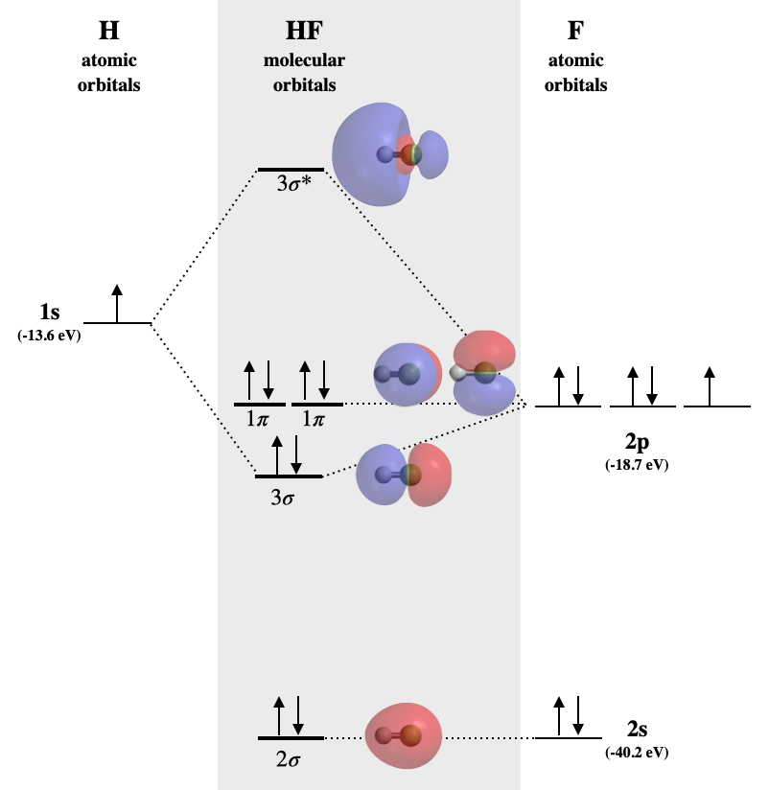

Chem.LibreText: Molecular Orbital diagram of hydrogen fluoride. Molecular orbitals calculated using Spartan software. (Kathryn Haas, CC-BY-NC-SA)

* 1. Does your MO diagram look similar? If not, call the instructor to discuss the energy interactions.
  2. To the right are pictures of the MO for HF. Look at the pictures for the p orbitals.
     1. Why do the p orbitals look like the F 2px and F 2py AO?
     2. Why do you think these orbitals are called “non-bonding orbitals.”
     3. Do you think you would include “non-bonding orbitals” in bond order calculations? Why or why not?
     4. What is the bond order for HF.
     5. Draw the Lewis structure for HF.
        1. Does the bond order match what you had in part iv?
        2. Do the number of bonding and non-bonding electrons match the MO diagram? Explain.
        3. The Lewis structure predicts all the non-bonding electrons are the same. Does the MO diagram support or contradict this idea?
  3. Based on electronegativity, is HF polar or nonpolar?
  4. Look at the interacting orbitals pictures and MO diagram.
     1. Why is the s* orbital situated more on H than on F?
     2. Why is the s orbital situated more on F than on H?
     3. Is the electron density in the molecule distributed more on the H or the F based on the MO diagram?
     4. How does the MO diagram support that HF is a polar molecule?

1. Look back at the MO diagram you drew for HF.
   1. The HOMO is the “highest occupied molecular orbital.” It is the orbital of the highest energy that has electrons. Circle the HOMO orbitals and write “HOMO” by them.
   2. The LUMO is the “lowest unoccupied molecular orbital.” It is the orbital with the lowest energy that is still empty. But a box around the LUMO orbitals and write “LUMO” by it.

Reactions often occur between the HOMO and LUMO of molecules so identifying them can be important.