Hybrid Orbitals within MO Theory

Although you can’t ever form sp³ hybrid orbitals (unless you drop waaaaay down in symmetry), you can form sp hybrid orbitals in most “useful” point groups. I usually consider the C_{nv} and D_{nh} point groups (n ~ 3-4) to be the most useful for forming MO diagrams, and you should usually attempt to ascend or descend in symmetry to reach these. Note that n must be odd when you descend in most cases in order to fully realize the symmetry of the molecule. Look at the character tables for D_{nh} for n = 2, 3, 5, 6 and ∞ and see how x and y transform to get an idea of what I mean.
You almost always can form hybrids between s and d_{z2}, however, except for in the very high symmetry groups T_{d} and O_{h}. These orbitals will always have “A” symmetry of some sort. What do the 2 sd_{z2} hybrid orbitals look like? Lets construct them using a graphical approach. When taking a linear combination of 2 things, you either add them or subtract them as follows:

The top orbital is a big donut in the xy plane; the bottom orbital has most of its spatial orientation along +/- z.
If you are in a point group where s, p_{z} and d_{z2} all have the same symmetry (C_{3v} for example; can you see why a D_{nh} point group won’t let p_{z} have the same symmetry as s or d_{z2}?), they too can mix together. The most useful hybrid orbitals are the top one above, and then adding pz orbitals both in and out of phase to the lower one.
The top orbital has a large lobe pointing along +z, the bottom one has a large lobe pointing along –z, and we continue to keep the one in the xy plane. There are other possible combinations of s, p_{z} and d_{z2} in other geometries, but these are likely to be the most useful.

Some additional hybrid orbitals useful for VBT in Transition metal compounds.
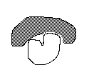
In T_{d}, the (p_{x}, p_{y}, p_{z}) and (d_{xy}, d_{xz}, d_{yz}) orbitals both have T₂ symmetry and can hybridize as follows.

Here is a calculated MO diagram (partial) for NiH₄⁻² (in T_{d}); Energies in eV. The calculation was done at a fairly high level using Gaussian and the WebMO interface. The MO’s show the d-p hybrids shown above. The energies of the 4 H atoms and of the Ni atom are approximate only. The 4s orbital was calculated to be higher than the 4p; I am not sure why that is the case. Also, I would normally put the A₁ σ* above the T₂ σ*, but this is what Gaussian said.

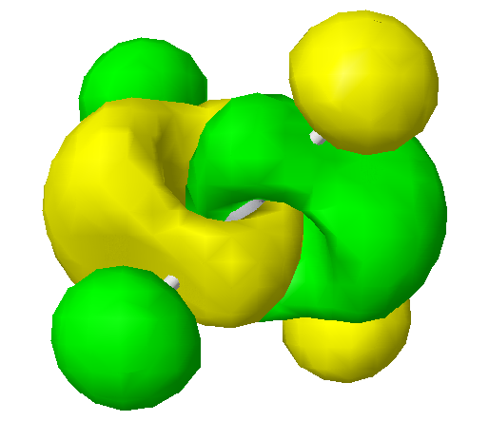
T₂ σ* 6.81
A₁ σ* 4.56
T₂ nb 3.50
E nb -0.58
T₂ σ -1.07
A₁ σ -1.42

