**Journal Article Discussion**

###### Copper Oxide Crystal Growth

*Read the following article and its Supporting Information.*

# Siegfried, M.J., and Choi, K-S, “Elucidating the Effect of Additives on the Growth and Stability of Cu2O Surfaces via Shape Transformation of Pre-Grown Crystals” J. Am. Chem. Soc., 2006, *128* (32), pp 10356–10357

*Work the following problems to turn in:*

1. Define the following terms in the context of this paper:
   1. crystal habit
   2. interfacial
2. Why are the authors interested in controlling crystal habit?
3. a. What is the difference between {100} vs (100)?
4. Draw (100), (110), and (111) planes of a cubic crystal.

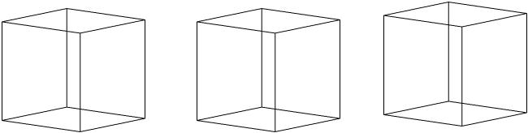

1. What was the purpose of the addition of SDS to the plating solution?

*Be prepared to discuss the following questions in class*

1. The Cu2O unit cell is shown below. Why is it primitive cubic (P) and not face centered cubic (F) in the Bravais Lattice system?

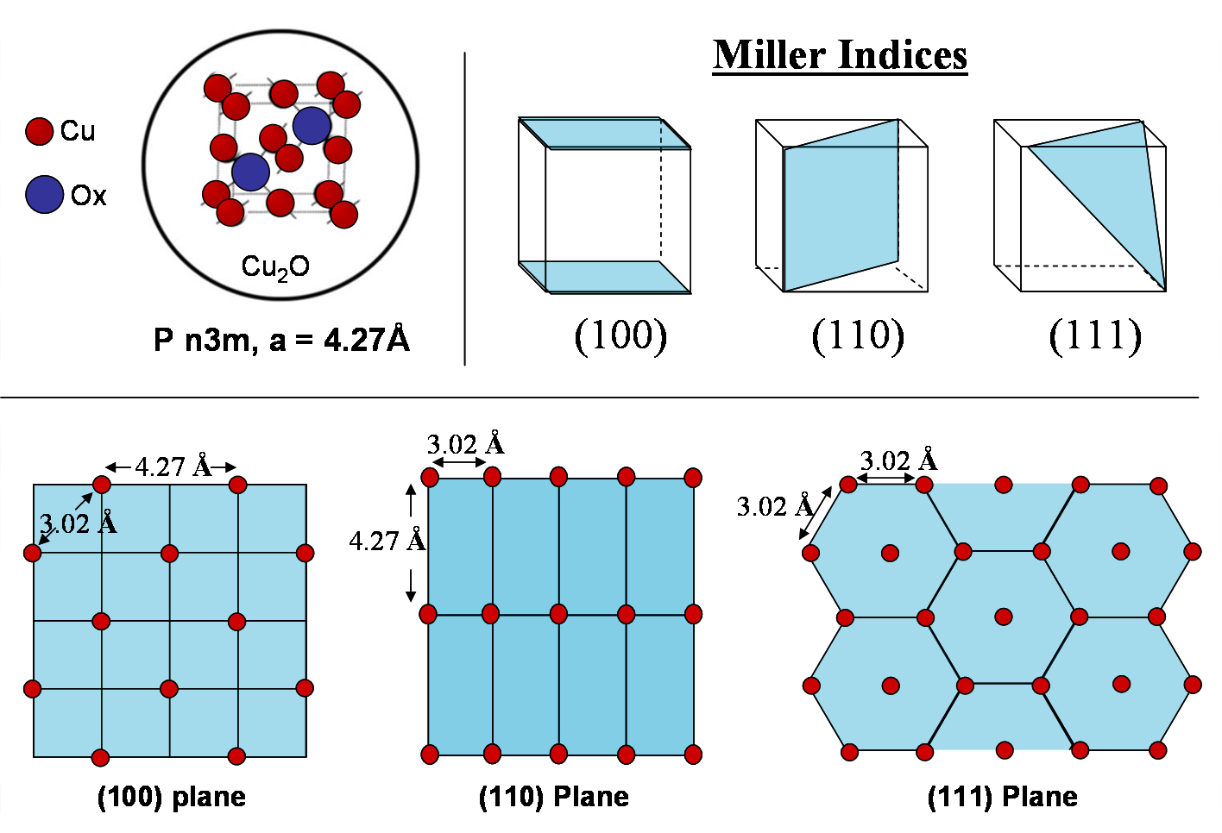

1. a. Draw a diagram of the **copper** atoms on the (100), (110), and (111) planes.

b. Where are the oxygen’s located?

1. How many oxygen atoms and how many copper atoms are in one unit cell of Cu2O?

d. Based on the placement of the copper and oxygen atoms, why might different interfacial crystal planes have different reactivities.

1. Using the XRD information in the supporting information answer the following questions:
2. Using Bragg’s Law and estimating 2Θ from the XRD, what is the d-spacing for the (200), (220), and (111) planes? Assume that 𝜆= 1.54 Å.
3. Using the d-spacing for the (111) plane, what is the length of “a” for Cu2O?