**Metal acac complexes**

**Week 2: synthesis of metal acac complexes**

1) brief prelab lecture/intro to the experiment over zoom.

2) dividing into teams. Each student will “carry out the synthesis” of either Mn(acac)3 or Co(acac)3. Then, your second reaction to analyze will either be Cr(acac)3, Fe(acac)3 or Cu(acac)2. Thus there will be 6 groups:

a) group 1: MnCr

b) group 2: MnFe

c) group 3: MnCu

d) group 4: CoCr

e) group 5: CoFe

f) group 6: CoCu

3) watch the videos for the synthesis of Mn or Co acac, and in your group, determine the balanced chemical reaction, the purpose of each reagent, and the yield. Then, do the same for Cr, Fe or Cu acac. Note that there are not videos to watch for these last three reactions, but you can base your work from the procedures written in the lab manual; you don’t need to calculate a yield. The instructor will provide information on purification by recrystallization, which you should also add to your writeup. Finally, as a team, determine the characterization data you *most* want to have in order to characterize your complexes. Remember, the point of characterization is to determine the identity (in this case, to *verify* the identity) and purity of the complex. Submit your proposed characterization methods, including a rationale. We will discuss this as a class at the beginning of week 2.

Videos:

<https://www.youtube.com/playlist?list=PLJb-VFt_wYH4vS3kuKvgLs7AHDKQPcwUQ>

for week 2, you only need to watch either Coacac3 or Mnacac3, and the recrystallization video. The remaining 3 videos will be viewed next week.

**Week 3: Characterization of metal acac complexes**

1) brief prelab lecture/intro to the experiment.

2) collecting back into teams. Each student will characterize either Mn(acac)3 or Co(acac)3. And one of Cr(acac)3, Fe(acac)3 or Cu(acac)2. Thus there will be 6 groups, same as last week.

a) group 1: MnCr

b) group 2: MnFe

c) group 3: MnCu

d) group 4: CoCr

e) group 5: CoFe

f) group 6: CoCu

3) watch the remaining videos for the characterization of the metal acac complexes, visible spectra, making evans tubes, and evans NMR. Based on your selection of the most useful characterization data you provided last week, you will be provided the corresponding data. Interpret the data you are given. Remember, the point of characterization is to determine the identity (in this case, to *verify* the identity) and purity of the complex. The instructor will help, and will provide additional data as necessary (in case your data is insufficient to confirm the identity and purity).

Videos:

<https://www.youtube.com/playlist?list=PLJb-VFt_wYH4vS3kuKvgLs7AHDKQPcwUQ>

The stars of the show: metal acac complexes!

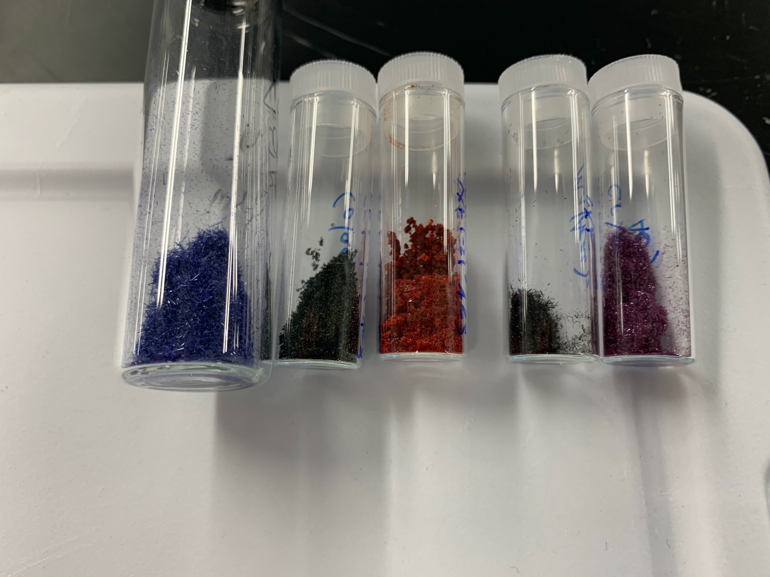

Cu Co Fe Mn Cr

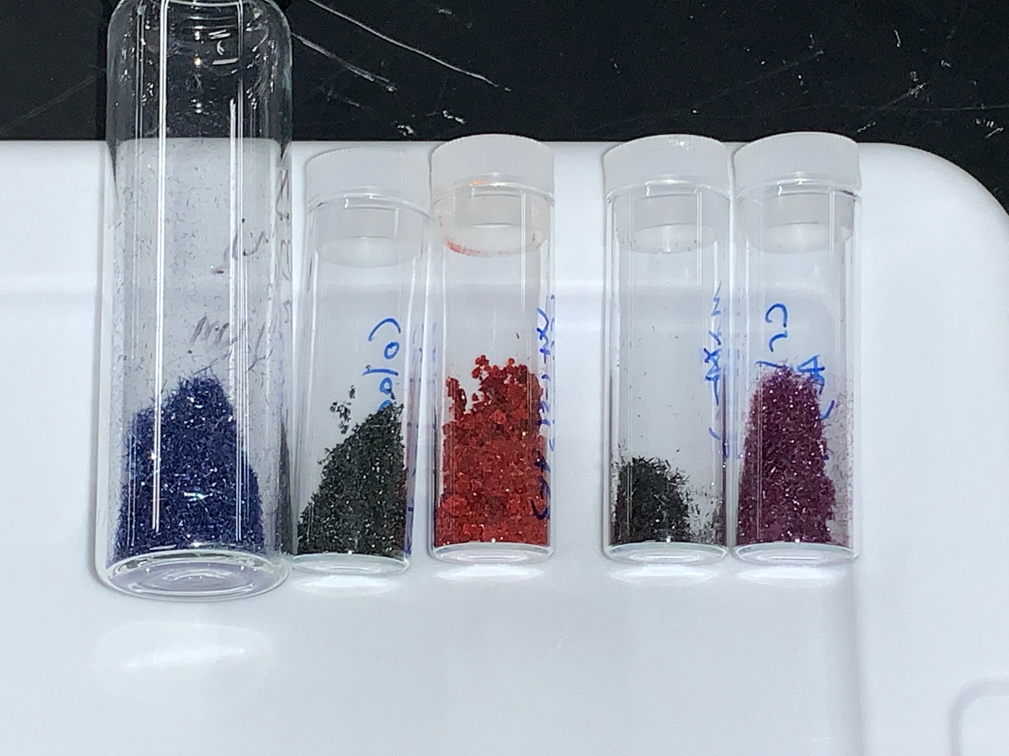

Cu Co Fe Mn Cr